|  |  |  |  |  |
| --- | --- | --- | --- | --- |
| **Grade 5** | **Lesson:**  **Traits of Organisms Part 8** | | Reference to English Interconnections Lesson  None | |
| **Science Standard(s): Standard 5 Objective 2** | | | | |
| **Content Objective(s):** | | **Language Objective(s):** | | |
| Students will be able to explain how a specific environment gives a species a survival advantage over another by playing a game in a small group.  ***I can explain how an environment promotes the survival of a specific plant or animal over another by playing a game in a small group.***  我可以通过在小组里玩游戏的方式，解释的环境如何促进某个特定的植物或动物的生存，而不是其它种。 | | Students will be able to orally state how environments help specific plants and animals survive and how the same environments would not permit other plants and animals to survive by presenting the information in a small group during a game.  ***I can explain how environments promote the survival of its plants and animals, and how environments would not permit the survival of other plants and animals by talking with friends in a small group during a game*.**  **我可以通过跟小组里的朋友玩游戏、讨论的方式，解释**解释的环境如何促进某个特定的植物或动物的生存**，而不允许其他种的植物和动物的生存。** | | |
| **Essential Questions:**  *How do the traits of plants and animals help them survive in their environments?* | | **Required Academic Vocabulary for Word Wall:**  **Listen:** Environment, habitat, promote, survival, permit, saltwater, freshwater, arctic, tropical rainforest, dessert, mountains, grasslands, forest  环境，栖息地，促进,生存，允许，咸水，淡水，北极，热带雨林，沙漠，山，草原，森林  **Speak:** Environment, habitat, promote, survival, permit, saltwater, freshwater, arctic, tropical rainforest, dessert, mountains, grasslands, forest  环境，栖息地，促进,生存，允许，咸水，淡水，北极，热带雨林，沙漠，山，草原，森林  **Read:** Habitat栖息地  **Write:**  **Sentence Frames:**  The ___________ (environment/habitat) promotes the survival of the _____________ (plant/animal) because ______________.  这个___________（环境/栖息地）促进______________（植物/动物）的生存，因为______________  The ___________(environment/habitat) would not permit the survival of the __________ (plant/animal) because __________.  这个___________（环境/栖息地）不允许______________（植物/动物）的生存，因为______________ | | |
| **Materials:**   * Picture of the Arctic Environment * Picture of the Tropical Rainforest Environment * Picture of the Salt Water Environment * Picture of the Freshwater Environment * Set of picture cards for teacher to use for practice (from previous lesson) * One set of picture cards pre-cut for each group of 4 students (from previous lesson) * One copy of the game board (laminated or on cardstock) for each group of 4 students (from previous lesson) * A gamepiece for each student (manipulatives) * Dice- one for each group of 4 students * Whiteboards, markers and erasers for each partnership of students | | **Additional Lesson Vocabulary:**  Fur, camouflage, skin, climate, temperature, home, food, fire prone, fire resistant, vegetation, elevation, rainfall  **毛皮，伪装，皮肤，气候，温度，家，食物，易发生火灾，防火，植被，海拔，降雨** | | |
| **Lesson:** | | | | **Instructional Time: 45 Minutes** |
| **Opening:** **(5 minutes)**  Hook: Post a picture of the arctic with animals and the picture of the tropical rainforest with the animals. “In our last lesson we talked about how the traits of plants and animals help them survive in their environments. Today we are going to focus on the environments and how they give one species a survival advantage over another.”  我们谈到植物和动物的特征如何帮助他们在他们的环境中生存。今天，我们要专注于环境和如何给一个物种生存优势，（使它比其他的物种更容易生存在环境中）  Question: “Look at this picture of the arctic environment. Could these animals survive in this environment? How do you know? Turn to your partners and discuss.”  “你看这幅画，北极环境。这些动物在这样的环境中可以生存吗？你怎么知道？跟你的伙伴讨论一下。   * Have a couple of students share their ideas.   Question: “Look at this picture of the tropical environment. Could these animals survive in this environment? How do you know? Turn to your partners and discuss.”  你看这幅画，热带雨林环境。这些动物在这样的环境中可以生存吗？你怎么知道？跟你的伙伴讨论一下。   * Call on a couple of students to share their ideas.   Question: “Could these tropical animals live in the arctic environment? Why or why not? Turn to your partners and discuss.” 这些热带动物可以生活在北极环境中吗？为什么或为什么不呢？跟你的伙伴讨论一下。   * Have a couple of students share their ideas.   Question: “Could these arctic animals live in the tropical environment? Why or why not? Turn to your partners and discuss.” 这些北极动物可以生活在热带环境中吗？为什么或为什么不呢？跟你的伙伴讨论一下。   * Have a couple of students share their ideas.   Explain: “Different environments have characteristics that promote survival for specific species of plants and animals. Other plants and animals may not be able to survive in that environment. Let’s look at our objective today.” 不同的环境促进特定种类的植物和动物的生存。其他植物和动物可能无法在这种环境中生存。让我们来看看今天我们的目标。  Introduce the Objectives: Have the students read the content as a class. Have Partner 1 tell Partner 2 one thing the class will learn today. Have Partner 2 tell Partner one how we will know that we learned it.  **Introduction to New Material (Direct Instruction): (15 minutes)**  Explain: “Let’s look at a couple of different environments and decide how they give certain species a survival advantage over others. Many of us think of water as the environment for fish. Did you know that there are two types of water that fish can live in? There is salt water and fresh water. Salt water is found in oceans and seas, and fresh water is found in lakes, rivers, ponds and streams. Most fish can only survive in one type of water. Salt water fish cannot survive in fresh water, and fresh water fish cannot survive in salt water. Both environments have salt, but salt water has much more. Oceans and seas with salt water can be very deep. Most plants and animals live in the more shallow waters where the sun can warm up the water. The deep parts of the ocean do not get sun, and they are dark and cold. The ocean and sea water is not actively moving. The tides can move some animals, but most animals have to move to get their food. Oceans and seas are typically larger than freshwater bodies of water and allow for larger plants and animals to survive, including whales, seals, dolphins, etc. Saltwater bodies also tend to have more colorful plants and fish. The majority of the earth is covered in salt water. Freshwater bodies tend to be smaller in size. Therefore, the plants and animals tend to be smaller in size, although there can be large fish found in larger lakes. They can also have deep parts and most of the plants and animals prefer the more shallow parts where the sun can light and warm the water. Usually plants and animals in freshwater bodies are less colorful. There are more browns and greens. Some freshwater is moving, such as in rivers and streams, and some fish and animals prefer to be still and stationary and let the food come to them. Freshwater makes up less than 1% of the world’s water. Let’s look specifically at these two types of environments and identify characteristics of these environments that give certain plants and animals a survival advantage over others.” “让我们来看看一些不同的环境，并决定它如何给某些物种的生存优势。许多人认为，水是鱼的生活环境。你知道吗，鱼能生活在两种水里。有咸水和淡水。盐水在海洋中。淡水湖泊，河流，池塘和溪流中。大多数鱼只能在一种水中生存。咸水鱼不能在淡水中生存，淡水鱼不能在咸水中生存。这两种环境中有盐，可是咸水中的盐更多。咸水的海洋是非常深的。大多数植物和动物生活在浅水水域，那里的阳光可以把水变得温暖。海洋的深处没有阳光，那里很黑，很冷。海洋和海水不是活水（不会积极地动）。潮汐可以移动一些动物，但大多数动物都要自己移动去找他们的食物。海洋通常大于淡水水体，并允许较大的植物和动物的生存，包括鲸鱼，海豹，海豚，等等。咸水水体也往往有更加丰富多彩的植物和鱼类。地球的大部分覆盖在咸水中。淡水水体往往比较小。因此，那里的植物和动物往往比较小。但也有可能在较大的湖泊中发现的大型鱼类。他们也可以有深水水域，但是那里的植物和动物更喜欢阳光可以照到的，温暖的浅水水域。通常淡水水体的植物和动物没有各种各样的颜色。它们大多数是棕色和绿色。一些淡水河流是动的/活的，比如河流和小溪，一些鱼类和动物更喜欢带着不动，固定在一个地方，等着食物过来。淡水在世界水体中占小于1％。让我们来看看这两种类型的环境。辨别一下这两种环境有什么的特征，让某些植物和动物的具有优于其他物种的生存优势。“Post pictures of salt water and fresh water environments.  Question: “Look at these two environments. Consider the types of plants and animals found in each. How does a saltwater ocean give these plants and animals a survival advantage over the freshwater plants and animals? Turn to your partner and discuss.” “看看这两个环境。考虑一下在这两个环境中分别可以找到什么样的植物和动物。一个咸水海洋如何给这些植物和动物优于淡水植物和动物的生存优势？跟你的伙伴讨论一下。“   * Have a couple of students share with the class what they discussed with their partners. * Question: “How does a freshwater lake or river give these plants and animals a survival advantage over the saltwater plants and animals? Turn to your partner and discuss.” “一个淡水湖如何给这些植物和动物优于咸水植物和动物的生存优势？跟你的伙伴讨论一下。Have a couple of students share with the class what they discussed with their partners.   Explain: “You had some great points and ideas! A saltwater ocean contains the salt these plants and animals need to survive. It often gives a larger environment for bigger species. It provides home and camouflage for many colorful fish. It provides plenty of space for fish to swim and plants to grow, and a lot of opportunities for food. Freshwater fish would not survive here because they cannot have that much salt. They would not have the appropriate homes or food. Some require moving water to bring them their food, and the ocean water typically doesn’t move. For the same reasons, saltwater fish could not survive in freshwater. They would not have enough space, appropriate homes or food, or the camouflage needed to survive. Each of these environments gives these plants and animals a survival advantage over others.” “你们的想法很棒！一个咸水海洋包含植物和动物生存的需要的盐。它给大物种提供了一个大环境。它给许多五颜六色的鱼提供了家和伪装。它给鱼游泳和植物的生长提供了充足的空间，以及找到食物的机会。淡水鱼不能在这里生存，因为他们不可以有那么多的盐。它们不能在这里找到适合的家或食物。有些需要移动水带给他们食物，海水通常不会移动。出于同样的原因，海水鱼无法生存在淡水中。他们没有足够的空间，适合的家或食物，或生存需要的伪装。每种环境都给这些植物和动物提供了生存优势。   * Go through a similar explanation and questioning process with these environments (these should be more familiar to students and should require less instruction):   + Arctic vs. Tropical (if the opening did not provide enough opportunity for instruction and discussion)     - Climate, vegetation, camouflage, fur/skin thickness, rainfall   + Dessert vs. Mountains     - Temperature, rainfall, camouflage, homes, vegetation, fire prone vs. fire resistant   + Grasslands vs. Forests     - Elevation, types of vegetation, camouflage, homes, fire prone vs. fire resistant   **Guided Practice: (10 minutes)**  Explain: “We are going to participate in a similar activity to our last lesson. However, instead of focusing on the traits of plants and animals and how they have adapted to the environment, we are going to focus on the environment. I want you to be thinking about this question today as we play our game: How does this environment give this plant/animal a survival advantage over the other plant/animal? We will use the same cards with different species of plants and animals and their habitats. I will mix them up and select two cards. I will display one card under the title Partnership A and the other under Partnership B. You will be working in partners and in groups. Each partnership will have a Partner 1 and a Partner 2, and each group will have a Partnership A and Partnership B. Partnership A will be looking at the habitats under their title, while Partnership B will be looking at the habitats under their title. First, you will need to work with your partner to identify your environments’ characteristics that promote the survival of that plant/animal. You may use a whiteboard to write down some notes to help you remember what you discuss. You do not need to write complete sentences. You will identify and explain with your partner how each environment promotes the survival of its specific plant/animal. You can use the sentence frame to help you but I recommend trying to use your own natural language.” 我们要做一个和上节课差不多的活动。可是，我们今天的重点不是植物和动物的特征，以及他们怎么适应环境。我们今天的重点是环境。我希望你们在玩游戏的时候思考着这个问题：这个环境如何给这些植物/动物生存优势，而不是其它的植物和动物？我们会用图片卡，上面有不同种类的的植物和动物和它们的栖息地。我会把它们混起来，然后选两张卡。我会把一张卡放在A组下，另外一张卡放在B组下。你们会和你们的伙伴一组。每一组会有一个伙伴1和一个伙伴2。A组和B组组成了一个大组。A组会看他们拿到的图片的栖息地。同样的，B组看他们组的。你们先跟伙伴一起，辨别什么特征促进那个植物/动物的生存环境的特征。你可以在白板上写你的笔记，帮助你记住你们讨论了什么。你不需要写出完整的句子。您会跟你的伙伴识别和解释每个环境是如何促进那个特定植物/动物的生存的。你可以用句子的框架来帮助你，但我建议你们用自己的话来说。“Post the sentence frame:  The ______________(environment/habitat) promotes the survival of the _____________(plant/animal) because ____________. “ You will also explain how each environment would NOT help the other plant/animal survive. Again, you can use the sentence frame to help you but I recommend trying to use your own natural language  这个___________（环境/栖息地）促进______________（植物/动物）的生存，因为______________  你也要解释为什么这个环境不会帮助其他植物/动物生存。同样，你可以用句子的框架来帮助你，但我建议你们用自己的话来说。  Post the sentence frame:  The ___________(environment/habitat) would not permit the survival of the __________ (plant/animal) because ______________________.  这个___________（环境/栖息地）不允许______________（植物/动物）的生存，因为______________  “ Take good notes, because next you will explain your findings with another partnership. Partnership A will share with Partnership B, then Partnership B will share with Partnership A. Each partnership will identify the environments or habitats on their card. Partner 1 will look carefully at both environments and will explain how each environment promotes the survival of its plant/animal. Partner 2 will explain how each environment would NOT permit the survival of the other plant/animal. Then, Partnership B will share in the same manner. Afterwards, we will discuss our findings as a class for each set of plants or animals.”  “好好做笔记，因为等一下你要解释你发现了什么给另外一组的人听。A组会跟B组分享，然后B组会跟A组分享每一组都要辨别图片卡上的环境或栖息地。伙伴1会仔细看两种环境，然后解释每个环境如何促进植物/动物的生存。伙伴2会解释每个环境如何不允许其他植物/动物的生存。B组的伙伴1和伙伴2也一样。然后，我们会全班讨论我们的对每一套植物/动物的研究结果。  *Use the modeling cycle:*  *Teacher Does:*   * Use a puppet, stuffed animal or an imaginary group member to model. Post two cards on the board or under the document camera. Label one as Partnership A and the other as Partnership B. Talk with your imaginary partner and use the large class whiteboard to take notes about your two plants or animals under Partnership A. Discuss how their environments promote the survival of their plant/animal, and how the environments would not permit survival of the other plant or animal.   *Teacher Does with a Pair of Students:*   * Call up two students to help you model. Have them use the card under Partnership B to discuss environments and take notes on the large class whiteboard about their two environments and how they promote the survival of their plant/animal, and how they wouldn’t permit survival of the other plant/animal. As Partnership A, work with your imaginary partner to present your findings with Partnership B. Explain you will be Partner 1 and will explain how each environment promotes survival of its plant/animal. Your imaginary partner, Partner 2, will then explain how each environment would NOT permit the survival of the other plant/animal. Next, Partnership 2 will do the same.   *A Group of Students Do:*   * Call up four students to help you model. Use the same cards on the board to model once again what they should do. Label one pair of students Partnership A (with a Partner 1 and Partner 2) and the other pair of students Partnership B (with a Partner 1 and Partner 2). Each partnership will use a small whiteboard to take notes about their environments. They will discuss the environment and how it helps the plant/animal survive, and what makes it so other plants/animals couldn’t survive in the environment. Then the two pairs will share with one another. Partner 1 will explain how the environment promotes survival of its plant/animal, while Partner 2 will explain why the environment would not permit survival of the other plant/animal.   *All Students Practice:*   * Post a new set of pictures under Partnership A and Partnership B. Assign all students to be either Partner 1 or Partner 2, and Partnership A or Partnership B. Walk students through this process and have partnerships share out loud with the class what they discussed after all partnerships had a chance to share in their groups. Post another set of cards if you think the students could use more practice.   **Independent Practice: (12 minutes)**   * Explain: “Now you are going to play a game in your groups. You will all have a game board. Partnership A will be working together, and Partnership B will be working together. You will have two game pieces and a die. Each partnership will take turns rolling the die. They will move their game piece that many spaces. They will land on a square with a number on it. The number lines up with a particular card with plants/animals and habitats on it. That will be the card they use. They will need to discuss in their partnership, just as we did in the previous activity, how each environment promotes the survival of its plant/animal and how it would not permit the survival of the other plant/animal. Partner 1 will share how the environment promotes the plant/animal’s survival, and Partner 2 will share the environment would not permit the survival of the other plant/animal. Then, the next Partnership will roll the die and move. Each partnership can use the whiteboard to help them if they want, but they don’t need to.” “现在你们要在大组里面玩一个游戏。你们都会有一个游戏板。A组会一起玩，B组会一起玩。你会有两个棋子和一个骰子。每组会轮流掷骰子。掷到几，就把棋子移动几步。棋子移到的方块里面有一个数字。这个数字就是你要拿的图片卡的数字。图片卡上会有植物/动物和它们的栖息地。你们会用那个卡。你们要跟你的伙伴讨论，跟我们之前做得一样。讨论一下每个环境是如何促进它的植物/动物的生存；如何不允许其他植物/动物的生存。伙伴1会分享环境如何促进植物/动物的生存，伙伴2会分享环境如何不允许其他植物/动物的生存。然后，另外一组会掷骰子。每一组可以用白板来帮助记笔记。如果不用，也没关系。 * The modeling cycle can be used to focus on the new procedures of the game. The language and much of the procedure is the same, so the entire cycle may not be necessary. * The teacher should walk around and ensure students are following the procedure, speaking orally, taking turns, and using the target language. Ensure that there is not one student in the partnership or group who is dominating the conversation.. You can walk around and write down observations to assess students and partnerships.   **Closing: (3 minutes)**  Revisit the Objectives: Have students reread the content objective as a class. Have students explain to their partners one new skill they learned today, and how they know they learned it. Have some students share with the class.  Real World Application: Tell students to take a walk through the mountains, desert or near a river or lake. Tell them to read a book about different environments, or look at pictures of different environments on the internet. Have them look for evidence that the environments promote the survival of different plants and animals in that environment. Have students ask themselves if these plants or animals could survive in a different environment. Give students an opportunity to share their thoughts and experiences during another class period. | | | | |
| **Assessment:** | | | | |
| Observe students during guided and independent practice. Observe their conversations in guided and independent practice to assess their mastery of the language objective. | | | | |
| **Extra Ideas:** | | | | |
|  | | | | |

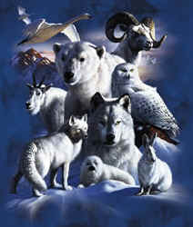

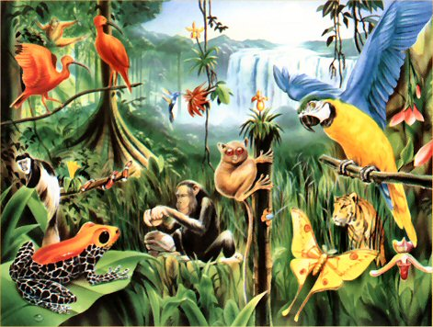

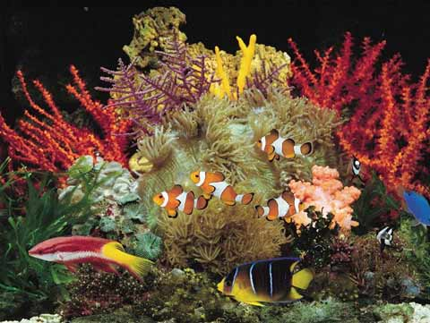

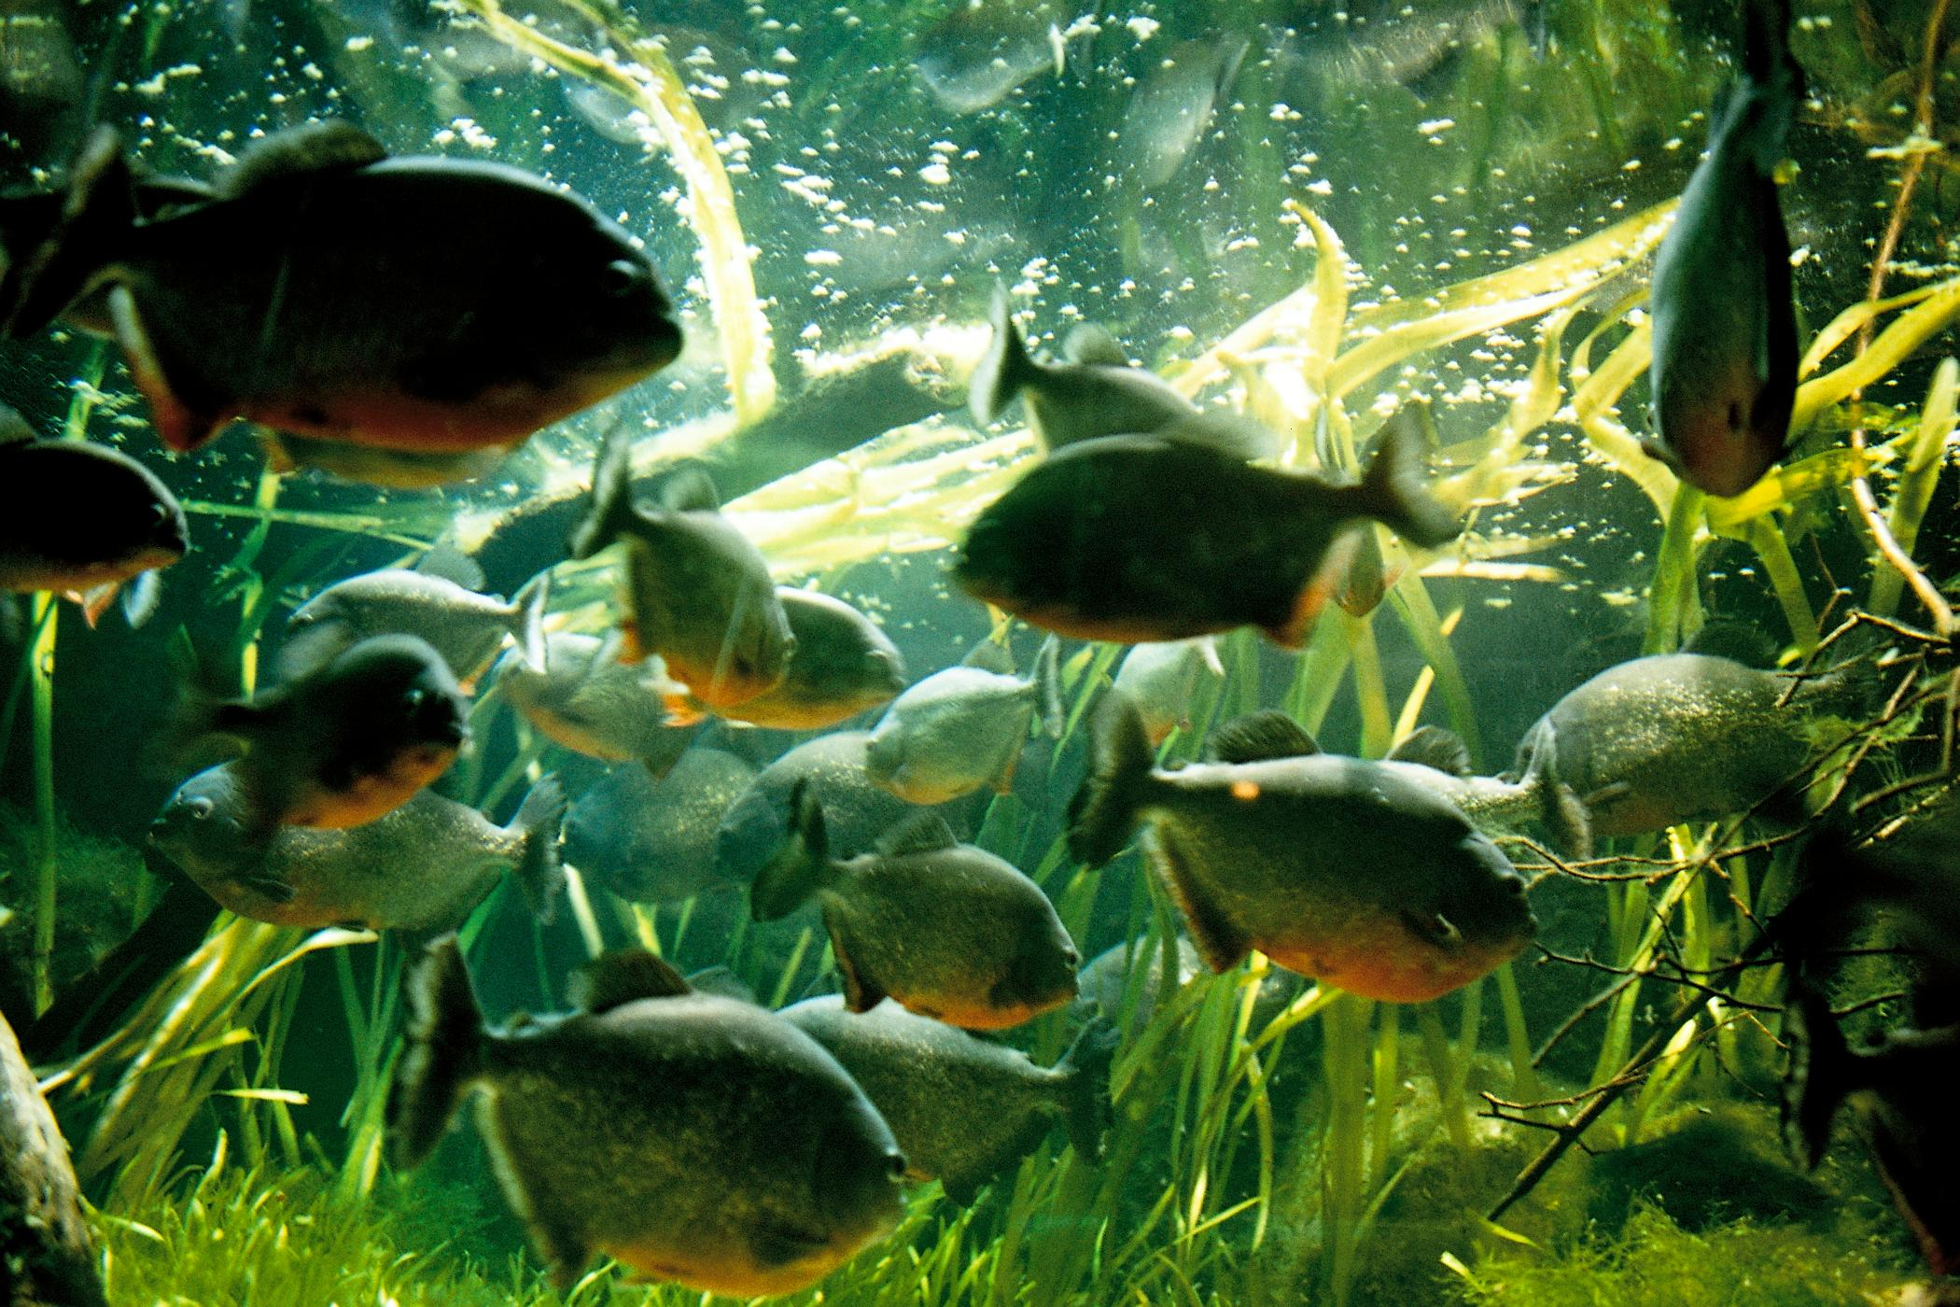

|  |  |  |  |
| --- | --- | --- | --- |
|  |  |  |  |



|  |  |  |  |
| --- | --- | --- | --- |
|  |  |  |  |





|  |  |  |  |
| --- | --- | --- | --- |
|  |  |  |  |



|  |  |  |  |  |  |
| --- | --- | --- | --- | --- | --- |
|  |  | |  |  | |
| **Green Sea Turtle  Species6**  **Green Sea Turtle**  Habitat: Worldwide in sub-tropical and tropical oceans such as off the Florida Coast and Gulf of Mexico.  绿海龟  栖息地：全球范围内，在亚热带和热带海洋，如在佛罗里达海岸和墨西哥湾。  Desert Tortoise  Species  **Desert Tortoise**  Habitat: Mojave and Sonoran Deserts of California, Nevada, Arizona, and Mexico. Lives among bushes, yucca trees and desert grasslands.  沙漠龟  栖息地：美国加州的莫哈韦沙漠和索诺兰沙漠，，内华达州，亚利桑那州和墨西哥。生活在灌木丛，丝兰树和沙漠草原里。 | | **https://encrypted-tbn0.gstatic.com/images?q=tbn:ANd9GcQprXi9c5LfyCsLMhczP3tCzWiz6XgchYukc1j8DYp3OzSTkGn8Lg9**  **Fennec Fox**  Habitat: Sahara Desert of North Africa, desert climates  小狐狐  栖息地：北非的撒哈拉大沙漠，沙漠气候  https://encrypted-tbn1.gstatic.com/images?q=tbn:ANd9GcTcLh_gcfAiU05NptB6LIRT7nEGIbQ5EcIs1H8zkjPbOvgjCZJPPg  **Arctic Snow Fox**  Habitat: Greenland, Russia, Canada, Alaska and other arctic ice lands. They live in dens off of a hill, cliff or riverbank.  北极雪山飞狐  生栖息地：格陵兰，俄罗斯，加拿大，阿拉斯加和其他北极冰地。他们住在小山、悬崖或河岸的洞穴中。 | | |
| **http://3.bp.blogspot.com/-VZoszsCdjPw/TgVB4_Nk7XI/AAAAAAAADiw/jXT7D5U2y3M/s320/Kristen%2BMartyn-%2BTwo-Lined%2BSalamander%2B%25281%2529.JPG2**  **Two Lined Salamander**  Habitat: Forests, shrublands, rivers, marshes, springs in Canada and the United States.  双线蝾螈  栖息地：森林，灌木丛，河流，沼泽，加拿大和美国的泉水中。  https://encrypted-tbn0.gstatic.com/images?q=tbn:ANd9GcRpDMJFHqJKFjfABtJBHyTF9Ljii_VSAnv4kCWrn3cfSlVQKK7PGQ  **Tiger Salamander**  Habitat: Mountainous areas and lowlands. They avoid the water and prefer the shelter of rocks and boulders.  虎蝾螈  栖息地：山区和低地。它们不喜欢水，喜欢藏在岩石和石块附近。 | | **https://encrypted-tbn0.gstatic.com/images?q=tbn:ANd9GcS6a2TNU_UqkEqHAF2VCkXcoub4eDy-Ad2ZrRl_mSn6QR0fJ6s_4**  **Leopard Gecko**  Habitat: Deserts in Asia, Pakistan and India.  豹纹壁虎  栖息地：在亚洲，巴基斯坦和印度的沙漠。  https://encrypted-tbn2.gstatic.com/images?q=tbn:ANd9GcSkOV3eejny-JD6A6VJoWMn02eK6u-iId-u70ydNnPLDufuNyk31Q  **Day Gecko**  Habitat: Islands near Indian Ocean, Africa, Hawaiian Islands, Madagascar and Florida. They live in coconut palms, banana trees, and in gardens.  日壁虎  栖息地：印度洋，非洲，夏威夷群岛，马达加斯加和佛罗里达附近的岛上。他们住在椰子树，香蕉树和花园中。 | | |

|  |  |
| --- | --- |
| **https://encrypted-tbn0.gstatic.com/images?q=tbn:ANd9GcSbun5wWpWJyMKpBo1pqErs83ADp5_yhCOKIN4z9bVf4lbSahDt1**  **Black Bear**  Habitat: North American forests with thick vegetation  黑熊  栖息地：北美有茂密的植被的森林中  https://encrypted-tbn1.gstatic.com/images?q=tbn:ANd9GcT57qz2GfolcKlQBCM_k3_pDtu4g7ESzhY9_nsY7afo3RiWxaug9A  **Polar Bear**  Habitat: Arctic areas, the sea, where the ice meets the water.  白熊  栖息地：北极地区，冰和水的交汇处 | **5**  **Snowshoe Hare**  Habitat: Young forests with lots of trees, brush and grass for cover.  雪兔  栖息地：有很多树木的年轻森林里，藏在灌木丛刷和草中。  https://encrypted-tbn1.gstatic.com/images?q=tbn:ANd9GcTnRn8ZABBI9HqGwEH_Pd2dq6MSTGe-7PTtHj-FhvoFs8Rh_Ppkmg  **Black-tailed Jackrabbit**  Habitat: Deserts in Western United States and Mexico. They live in shrub-grassland terrains in the desert.  黑尾杰克兔  栖息地：美国西部和墨西哥的沙漠中。他们生活在沙漠的灌木草原地形中。 |
| **https://encrypted-tbn1.gstatic.com/images?q=tbn:ANd9GcQu90CFapxuLBnXICUPc5F3arMbo2M9B00iA9gXKJdYC2YWoRCN1w12**  **Emperor Penguins**  Habitat: Antarctica near ice cliffs.  帝企鹅  栖息地：南极洲附近的冰崖。  https://encrypted-tbn3.gstatic.com/images?q=tbn:ANd9GcRs3Yyc-Hfha0Mez-y-kM8ZMLe6lnNaCH6sHg1kjD-ShBxb_oe9tg  **Galapagos Penguins**  Habitat: Galapagos Islands, tropical waters.  加拉帕戈斯企鹅  栖息地：加拉帕戈斯群岛，热带水域。 | **https://encrypted-tbn0.gstatic.com/images?q=tbn:ANd9GcQxVny_9akfTdMpd9erOg8fI0BLpJUH6HOwQNwrWkfqGrUV43GDGQ14**  **Mandarin Perching Duck**  Habitat: Densely wooded areas with waterways and marshes in Asia, Great Britain, Ireland and parts of the United States. Can be found perched in high trees.  国语栖息鸭  栖息地：亚洲，英国，爱尔兰和美国的部分地区，生活在有水道和沼泽的树木繁茂地区。栖息在高大的树木上。  https://encrypted-tbn2.gstatic.com/images?q=tbn:ANd9GcQjE-pQTIx-2SP9GoXmZ4_CQS58hnMQiViFLkFO5nHEWIfi6unm  **King Eider Duck**  Habitat: Arctic waters of Europe, North America and Asia. They are sea ducks and gather on coastal waters.  王绒鸭  栖息地：欧洲，北美和亚洲的北极海域。他们是海鸭，聚集在沿海水域。 |

|  |  |
| --- | --- |
| **https://encrypted-tbn1.gstatic.com/images?q=tbn:ANd9GcS9oCIEHeHUurgT7Gc3BZfDcd6PEYDdCfCHO-WN3hACTj9984tv3A13**  **Gorgeted Puffleg Hummingbird**  Habitat: Tropical rainforests in Colombia, South America.  Gorgeted Puffleg蜂鸟  栖息地：哥伦比亚，南美洲的热带雨林中。  https://encrypted-tbn3.gstatic.com/images?q=tbn:ANd9GcTWPB4tJ5rpHNPUEgimZQIdmLmeEEGGQCQ7T95gbeUmzEaGCLsl  **Northern Spotted Owl**  Habitat: Forests with many trees in North America and Canada.  北方斑点猫头鹰  栖息地：北美和加拿大的有很多树的森林中。 | **https://encrypted-tbn2.gstatic.com/images?q=tbn:ANd9GcRl8lm8MaEJsHU5vIknbtq49JMT081zFFlJiuK9bKmoaom7Ortn8**  **Clownfish**  Habitat: Saltwater from oceans or seas.  小丑鱼  栖息地：海洋的咸水中。  https://encrypted-tbn1.gstatic.com/images?q=tbn:ANd9GcS9Z_U4kNqMwN1KW3Sm5YXQKJb3Hexik_8SQ8k9MkIvzlG9S7-Etg  **Goldfish**  Habitat: Freshwater ponds or lakes.  金鱼  栖息地：池塘或湖泊淡水中。 |
| **https://encrypted-tbn3.gstatic.com/images?q=tbn:ANd9GcTV61-_zzVQ4CIq5ImT4YxEBaGgBOHA9ZXflTtegmPdR94LLpPxfg10**  **Utah Juniper Tree**  Habitat: Southern Utah, Nevada, and Arizona in dry ground such as the dessert or rocky soil.  犹他州瞻博树  栖息地：南犹他州，内华达州和亚利桑那州的土地中，比如沙漠或岩石土壤中。  http://www.blueplanetbiomes.org/images/samauma.jpg  **Kapok Tree**  Habitat: Tropical rainforests in South America, Africa, Indonesia and Asia.  木棉树  栖息地：南美，非洲，印尼和亚洲的热带雨林中。 | **http://upload.wikimedia.org/wikipedia/commons/thumb/a/aa/Bambusa_oldhamii_form.jpg/220px-Bambusa_oldhamii_form.jpg3**  **Bamboo**  Habitat: Tropical and subtropical areas of Asia, especially in the wet tropics  竹  栖息地：亚洲的热带和亚热带地区，尤其在潮湿的热带  https://encrypted-tbn1.gstatic.com/images?q=tbn:ANd9GcROi1_Q_hkHsy67WVNA68zQC9XheYgMZotM5_9Gq08WSdXmj2EdDA  **Cactus**  Habitat: Deserts, hot and dry land  仙人掌  栖息地：沙漠，炎热和干燥的土地中 |

|  |  |
| --- | --- |
| **https://encrypted-tbn1.gstatic.com/images?q=tbn:ANd9GcRwfvd7EqxBdvjOP5dqFYpZbgWJX68XIEq3erp9qppGVq5DRVD97**  **Ferns**  Habitat: Shady, moist conditions of tropical rainforests and other forests.  蕨类植物  栖息地：热带雨林和森林的阴凉，潮湿的环境中。  http://farm4.staticflickr.com/3534/3939582382_251cace4da_z.jpg  **Sagebrush**  Habitat: Western United States deserts with dry, rocky  SAGEBRUSH  栖息地：美国西部干燥的，有岩石的沙漠中。 | **https://encrypted-tbn1.gstatic.com/images?q=tbn:ANd9GcSeLPv-l96MLmZDSg5nMciYaWHG8LWOfbnOkMiXVglSxjXDczrbHA11**  **Hibiscus**  Habitat: Sub-tropical to tropical regions of the world  槿  栖息地：亚热带到热带地区。  **Calochortus nuttallii (Sego lily) #640**  **Sego Lily**  Habitat: Dry, brushy and grassy slopes, desert high country.  西格百合  栖息地：干燥的，有灌木的，有草的斜坡上，沙漠高的国家。 |