Grade 5 | Lesson:  Traits of Organisms Part 4  Offspring Life Cycles |  | Reference to English Interconnections Lesson  Cause & Effect: Inheriting Traits pg. 101
Science Standard(s): Standard 5 Objective 1
Content Objective(s): |  | Language Objective(s):
Students will be able to demonstrate the life cycle process particular species go through in order to resemble their parents by creating a life cycle poster in a small group.  I can demonstrate the life cycle process some species go through to physically look like their parents by creating a life cycle poster in a small group.  我可以在小组内做一个生命周期的海报，在这个海报上，我可以示范一个特定的物种所经历的生命周期。 |  | Students will be able to identify the stages of the life cycle for different morphing organisms and explain the changes in their physical traits by playing a game with a partner.  I can state the stages of the life cycle for different organism and explain how their physical traits change by playing a game with a partner.  我可以陈述不同生物生命周期的阶段。通过玩游戏，我可以跟一个伙伴解释生物的生理特征是怎么变化的。
Essential Questions:  How can you provide evidence that shows traits are passed from parent to offspring? |  | Required Academic Vocabulary for Word Wall:  Listen: organism, parent, offspring, life cycle, stage, morph, physical traits  生物、亲体、后代、生命周期、阶段、变形、生理特征  Speak: organism, parent, offspring, life cycle, stage, morph, physical traits  生物、亲体、后代、生命周期、阶段、变形、生理特征  Read:  Write: organism, parent, offspring, life cycle, stage, morph, physical traits  生物、亲体、后代、生命周期、阶段、变形、生理特征  Sentence Frames:  A ________________ begins as a ______________________.  Next the _____________ becomes a ___________ by _________________.  Then the ____________ becomes a ___________ by _________________.  Finally, the __________ became a ____________ by _________________.  Its physical traits change by _____________.  一个________________从________________开始。  然后______________ __________________阶段变成________________  然后______________ __________________阶段变成________________  最后______________ __________________阶段变成________________  它的生理特征__________________阶段变化了。
Materials:  - Vocabulary card  - Large larva and salamander cards  - Large Butterfly Life Cycle picture card  - Small life cycle cards (1 copy for each partnership)  - Large chart paper  - Crayons, colored pencils, markers, etc. |  | Additional Lesson Vocabulary:  Tadpole, metamorph, frog, egg, caterpillar, chrysalis, butterfly, pupa, beetle, ladybug, nymph, dragonfly, larva, salamander, seed, seedling, growing tree, mature tree with fruit, zoea, megalopa, crab, grasshopper, house fly, shoot, roots, trunk, branches, leaves, fruit, legs, tail, abdomen, wings  蝌蚪、变态、青蛙、卵，毛毛虫、蛹、蝴蝶、蛹，甲虫、蛹、瓢虫、蛹、蜻蜓、幼虫、蝾螈，种子，种苗，种植树，成熟的水果树，蚤状幼体，大眼幼体，蟹，蝗虫，苍蝇，芽，根，树干，树枝，叶子，水果，腿，尾巴，腹部，翅膀
Lesson: |  |  |  | Instructional Time: 45 Minutes
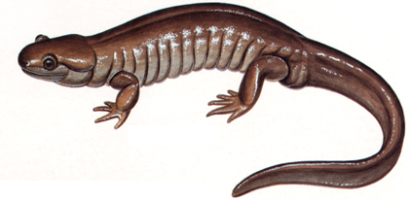
Opening: (5 minutes)
Hook: Post the large picture of the larva and the large picture of the salamander.
Question: “Are these two organisms parent and offspring? Why or why not? Turn to your partners and discuss.”
这两种生物是亲体和后代吗？为什么是？为什么不是？跟你的伙伴讨论一下。
- Have the students get into groups of four share what they discussed. Have groups share what they discussed.
Explain: “This may surprise some of you, but these two organisms are in fact parent and offspring. They are the same organism.”
可能你们有些人不相信，可是这两种生物事实上是亲体和后代。它们是一样的生物。
Question: “I know we just learned that offspring look like their parents. So how is this possible? How is it that these two look so different, but are still parent and offspring? Turn to your partners and discuss.”
我知道我们刚刚学了后代跟它们的亲体看起来很像。所以这怎么可能？怎么这两个看起来很不一样的生物，却是亲体和后代呢？
- Have a couple of students share what they discussed.
Explain: “Yes, there are some organisms that have a morphing process. They first are born, they do not look like their parents. They must go through stages of changes until they mature. Once they are adults they look like their parents.”
对，有些生物有变态的过程。它们出生的时候不像它们的亲体，它们必须经过变化的阶段，才能成熟。当它们成熟的时候它们才像它们的亲体。
Introduce the Objectives: Have the students read the content objective with their partners and tell each other one new skill they want to have by the end of this lesson.

Introduction to New Material (Direct Instruction): (10 minutes)
Explain: “Some plants, insects and animals don’t look like their parents at first. They have to go through a metamorphosis process and they will look like their parents once they are in their adulthood. The series of changes an organism goes through in its lifetime is called a Life Cycle.” 有些植物、动物和昆虫开始的时候跟它们的亲体不像。它们必须经历一个变态的过程。当它们进入成熟阶段的时候，它们会跟它们的亲体长得像。一个生物一生中所经历的这一系列的变化叫做“生命周期”。Show vocabulary card. “For many of these organisms, there are three or four stages they go through as they grow. In each stage, their physical traits and characteristics change. When they are in their final stage, they are an adult and look like their parents. We are going to learn about life cycles of specific organisms and discuss the changes in physical traits an organism experiences in each developmental stage. Let’s take a look at one of the organisms we are all very familiar with—a butterfly.”
很多的生物，在它们成长的过程中，要经历三个或者四个阶段的变化。在每一个阶段，它们的生理特征和特点会变化。当它们在最后阶段的时候，它们是成熟体，它们看起来像它们的亲体。我们要学特定生物的生命周期，讨论一个生物在每个阶段经历的生理特征。我们来看看我们都很熟悉的一种生物—蝴蝶。
Display the large picture of the life cycle of a butterfly and the small card. “A butterfly first starts as an egg. Out of the egg comes a caterpillar.” 一只蝴蝶最开始的时候是一粒卵，卵里面出来一条毛毛虫。
Question: “Does the caterpillar look like its parent the butterfly? Why or why not? Turn to your partners and discuss.”
毛毛虫看起来像它们的亲体蝴蝶吗？为什么是？为什么不是？跟你的伙伴讨论一下。
- Have a couple of students share with the class what they discussed with their partners.
Explain: “There are some traits we might be able to see that are similar between the caterpillar and the butterfly, but you’re right—the caterpillar does not really look like its parent the butterfly. It must go through a metamorphosis as it develops. It changes from a chrysalis into a butterfly. A chrysalis is a pupa that is enclosed in a hard case or cocoon. Although we cannot see inside of this casing, we know that the caterpillar is now a pupa.”
我们可以看见毛毛虫和蝴蝶有些相似的特征，可是你们说得对—毛毛虫看起来不太像它们的亲体蝴蝶。它要必须要经历一个变态的过程。它从蛹变成蝴蝶。一个蛹被包裹在一个硬壳里或者茧里。虽然我们看不见壳里面，可是我们知道现在毛毛虫变成了蛹。
Question: “How have the physical traits of the caterpillar changed as it morphed into a pupa or chrysalis? Turn to your partners and discuss.”
毛毛虫变态成蛹的过程中，它的生理特征发生了什么变化？跟你的伙伴讨论一下。
- Have a couple of students share with the class what they discussed with their partners.

Explain: “Yes, the caterpillar is now enclosed in a casing. It is changing so that it no longer has many legs. It no longer has a long wiggly body. It is developing wings. Inside of the casing it is wet and the wings are wrinkly. It is hanging upside down by silk. Let’s look at the last stage. It is changing from a chrysalis to a butterfly.”
对，现在毛毛虫被包裹在壳里面。因为毛毛虫发生了变化，所以它不再有那么多脚了，它不再有一条长长的会蠕动的身体。它长出了翅膀。壳里面是湿的，翅膀是皱的。它头朝下被丝吊着。我们来看看最后一个阶段。它从蛹变成了一只蝴蝶。
Question: “How have the physical traits of the chrysalis or pupa changed as it morphed into a butterfly? Turn to your partners and discuss.”
蛹变态成蝴蝶的过程中，它的生理特征发生了什么变化？跟你的伙伴讨论一下。
- Have a couple of students share with the class what they discussed with their partners.
Explain: “Yes, the pupa now left the casing. It has large wings that are dry and developed. It can fly. The butterfly now has six legs and a short abdomen. Throughout this morphing phase, the physical characteristics of this organism changed with each stage. When it reached adulthood, the butterfly now looks like its parents. It finally has the same physical traits as its parents after is morphing stages.”
对，现在蛹离开了壳。它有干的，发育好的翅膀。他会飞。蝴蝶现在有六条腿和一个短的腹部。在整个变态的过程中，这个生物的生理特征在每个阶段都有变化。当它到达成熟阶段的时候，蝴蝶就可以像它的亲体一样飞了。当变态完成以后，它最终可以有和它的亲体一样的生理特征。

Guided Practice: (12 minutes)
Explain: “You are going to be working with a partner to identify the changes in physical traits in different organisms as they morph. You will take turns selecting a card and identifying the different stages of development for the organism. With each stage you will explain how the physical traits have changed. We have some sentence frames to guide us in these conversations, but it is not necessary to use them. Just ensure you are identifying the stage, what the organism has become, and explaining the changes in physical traits.” 现在我们要跟一个伙伴一起辨别不同的生物在变态过程中的生理特征变化。你们会轮流选择一张图片卡，然后辨别那个生物发展的各个阶段。你要解释生理特征在每个阶段是如何变化的。我们有一些句子框架来帮助我们，可是我们不是一定要用到这些句子框架。只是在你辨别各个阶段的时候，确保你说了这个生物变成了什么，以及解释它生理特征的变化。Display sentence frames.

Use the modeling cycle:
Teacher Does:
Use puppets, stuffed animals or imaginary group members to model. Pick out a card. “A frog begins as an egg. The egg becomes a tadpole. Its physical traits change from a small organism yet to be born to a swimming organism with a long tail and big eyes. It has tiny back legs. Now my partner will explain the next step. The tadpole then becomes a metamorph. It loses the long tail and it becomes a short tail. It gains front legs and starts to look more like a frog. Now it is my turn again. The metamorph finally becomes a frog. It loses its tail completely and uses all four of its legs to hop around. It can swim in water by kicking, but no longer has a tail to help it swim. It now looks like its parents. Now it is my partner’s turn to select a new card.”
一只青蛙最开始是一颗卵。这颗卵变成了蝌蚪。它的生理特征从一个未孵化的小生物变成了一个有长尾巴和大眼睛的，会游泳的的生物。它有很小的黑腿。现在我让我的伙伴来解释下一个阶段。这个蝌蚪然后变成了？？？（don’t know how to translate this）。它的长尾巴不见了，变成了短尾巴。它长出了前腿，开始看起来像一只青蛙。现在轮到我来说。???最后变成了一只青蛙。它最后失去了尾巴，用它的四条腿跳来跳去。它可以蹬腿在水里游泳，可是没有尾巴来帮助它游泳。现在它像它的亲体了。现在轮到我的伙伴来选一张新的图片卡。
Teacher Does with a Student:
Call up a student to help you model. Pick out a card. Take turns identifying the stage and explaining how the organism’s physical traits have changed. “A tree with fruit begins as a seed. The seed becomes a seedling. It breaks out of the seed casing and starts to grow a shoot and roots. It grows and breaks through the soil.” 一棵水果树最开始的时候是一粒种子。这粒种子变成了种苗。它钻出种子的外壳，开始生长成芽和根。它长啊长，从土壤里长出来。The student explains the next step. “The seedling becomes a growing tree. It gets branches, leaves and a trunk.” “The growing tree becomes a mature tree with fruit. It has bigger, fuller branches and it now has fruit that contain seeds. It is taller and the trunk is thicker. It is now a mature tree that looks like its parents.” 种苗慢慢地变成了一棵生长的树。它长出了树枝、叶子和树干。这棵生长的树变成了一棵成熟的果树。它有更大的，更饱满的树枝，现在它有了水果/果实，果实里面有种子。树更高了，树干更粗了。现在这棵树变成了一棵成熟的树，看起来就像它的亲体一样。
Two Students Do:
Call up two students to help you model. Pick out a card. Have the students take turn identifying the stage and explaining how the organism’s physical traits have changed.

All Students Practice:
Pass out a set of cards to each partnership. Have them begin the activity and take turns identifying the different stages and explaining how the organism’s physical traits have changed. Display the sentence frames, but encourage students to use natural language to discuss the development of each organism.
Independent Practice: (20 minutes)
Explain: “Great practice! You will now be working in small groups. Each of your groups will receive one of the organism cards. Your group will be creating a poster to show the steps of the organism’s life cycle. You must include sentences to explain the changes in physical traits and the process the organism goes through. When we are finished, your group will present your poster to the class. Each member of the group will take turns explaining one of the stages and how the organism’s physical traits changed during that stage.”
练习地很好！现在你们要和你们的伙伴们一组，每一组会拿到一张生物的图片卡。你的组要制作一张海报。在海报上，你要向大家展示这个生物生命周期的阶段。在海报里，你也要写上句子来要解释生理特征的变化和生物所经历的过程。当我们做完以后，你的组会跟全班同学展示和报告你的海报。每一个组员都会轮流解释一个阶段：在那个阶段中生物的生理特征是如何变化的。

- Break the students up into groups of 4. Give them crayons, colored pencils, markers, etc. and a large chart paper. Give them the freedom to represent and draw the life cycle however they would like. Be sure to emphasize they need to include sentences on their poster for each of the stages naming that stage and explaining how the physical traits change. Reference the sentence frames that they can use as a guide. If students need more modeling, use the modeling cycle to create a sample poster. After 10-15 minutes, have each group come up and present their poster. Each member of the group should take turns explaining the different stages and the physical traits that change. The students should be familiar with the language needed for the presentation, but if they need more modeling, use the modeling cycle.
Closing: (3 minutes)
Revisit the Objectives: Have students reread the content objective as a class. Have students explain to their partners one new skill they learned today, and how they know they learned it. Have some students share with the class.

Real World Application: Encourage students to research other organisms that have a life cycle in which their physical traits change as they grow and develop. Offer an incentive for students to discover other organisms, and provide an opportunity for them to share with the class their findings. Encourage students to look for evidence of these different stages of these organisms in the world around them. They may see lady bugs, grasshoppers, beetles and butterflies as they play outside or walk to school. Give the class opportunities to share what they observe and explain the stage and physical traits of the organism.
Assessment:
Observe students during guided and independent practice. Display their posters in the classroom and use them to assess the content objective. Observe their conversations during the guided practice and their presentations in front of the class to assess their mastery of the language objective.
Extra Ideas:

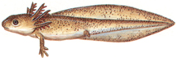

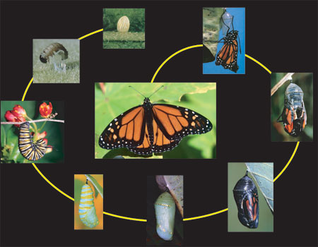

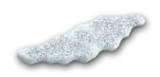  卵(luǎn) | 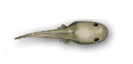  蝌蚪(kēdǒu)
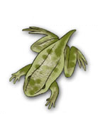  变形(biànxíng) | 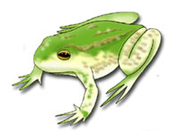  青蛙(qīngwā)

卵(luǎn) | 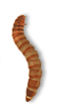  幼虫(yòuchóng)
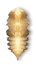  蛹(yǒng) | 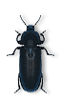  甲虫(jiǎchóng)

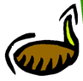  种子(zhǒngzǐ) | 幼苗(yòumiáo)
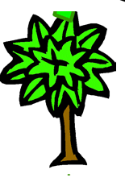  小树 | 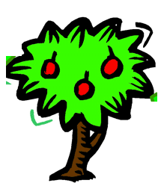  成熟(chéngshú)的果树，果树里有种子

卵(luǎn) | 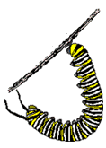  毛毛虫(máomáochóng)
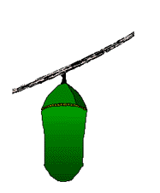  蛹(yǒng) | 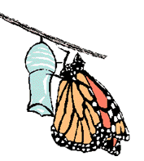  蝴蝶(húdié)

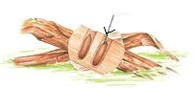  卵(luǎn) | 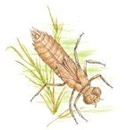  幼虫(yòuchóng)
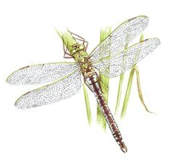
蜻蜓(qīngtíng)

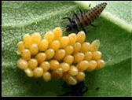  卵(luǎn) | 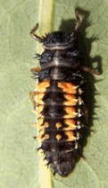  幼虫(yòuchóng)
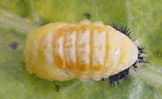  蛹(yǒng) | 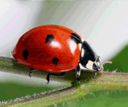  瓢虫(piáochóng)

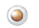  卵(luǎn) | 幼虫(yòuchóng)
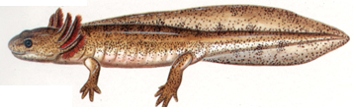  有腿的幼虫(yǒu tuǐde yòuchóng) | 蝾螈(róngyuán)

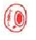  卵(luǎn) | 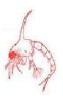  蚤状幼体(zǎozhuàng yòutǐ)
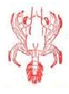  大眼幼体(dà yǎn yòutǐ) | 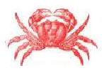  螃蟹(pángxiè)

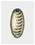  卵(luǎn) | 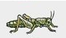  小幼虫(xiǎo yòuchóng)
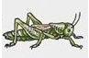  大幼虫(dà yòuchóng) | 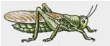  蚱蜢(zhàměng)

卵(luǎn) | 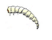  蛆(qū)
蛹(yǒng) | 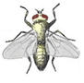  苍蝇(cāngyíng)

