Grade 5 | Lesson:  Electricity Part 3 |  | Reference to English Interconnections Lesson  Circuit Projects pg. 217
Science Standard(s): Standard 4 Objective 2
Content Objective(s): |  | Language Objective(s):
Students will be able to create a working model of a complete circuit by using a power source, switch, buzzer or light, and a conductor for a pathway with a small group.  I can create a model of a circuit by using a power source, switch, buzzer or light, and a conductor for a pathway with a small group of friends.  我可以跟一组伙伴一起创建一个电路的模型。在模型中，我要用到电源，开关，蜂鸣器或灯，作为路径的导体。 |  | Students will be able to name the components of an electrical circuit and describe the process of building a working circuit by participating in an experiment with a small group.  I can name the parts of an electrical circuit and explain how I built a working circuit by participating in an experiment with a small group of friends.  我可以跟一组伙伴一起做实验。在实验中，我可以说出电路中各个部分的名字，并解释我如何创建了一个可以工作的电路。
Essential Questions:  In what situations/materials will static electricity build up? How is the flow of electricity dependent on the type of material or the components of a circuit? |  | Required Academic Vocabulary for Word Wall:  Listen: electricity, electrical circuit, power source, path, pathway, load, control, indicator, conductor, insulator  电，电路，电源，路径，通路，负载，指标，导体，绝缘体  Speak: electricity, electrical circuit, power source, path, pathway, load, conductor, insulator  电，电路，电源，路径，通路，负载，导体，绝缘体  Read:  Write electricity, electrical circuit, power source, path, pathway, load, conductor, insulator  电，电路，电源，路径，通路，负载，导体，绝缘体  Sentence Frames:  Use sentence frames from the past two lessons.
Materials:  - Bandana and clothing for burglar  - Puzzle pieces of parts of a circuit from previous lesson  - 2 pieces of cardboard 5”x8” for each group of students  - 2 pieces of foil 3”x10” for each group of students  - 2 straws for each group of students  - Tape for each group of students  - Hole punch for each group of students  - 2-3 pieces of wire for each group of students  - 9v battery for each group of students  - A buzzer or a light bulb for each group of students  - Additional foil  - Additional cardboard  - Additional straws  - Additional tape  - Additional wire  - D batteries  - Paperclips  - Plastic spoons  - Wood blocks  - Sand paper  - File folders  - Thumb tacks  - Construction paper  - Blank paper for each group of students  - Quiz (1 for each student) |  | Additional Lesson Vocabulary:  Paperclip, battery, wire, light bulb, plastic spoon, straw, aluminum foil, cardboard, wood blocks, sand paper, file folders, thumb tacks, construction paper  回形针，电池，电线，灯泡，塑料勺，吸管，铝箔，纸板，木块，沙纸，文件夹，图钉，建设纸
Lesson: |  |  |  | Instructional Time: 50 Minutes
Opening: (4minutes)
Hook: Come in the classroom dressed like a burglar with a bandana over your eyes.
Question: “I am dressed like a burglar. Burglars steal things. Can you think of some things people do to protect their belongings? What are some things we can do with our new knowledge about circuits?”
“我穿的像一个贼。贼会偷东西。你们能想到的我们做什么事情可以保护我们的财物呢？我们用新学的电路的知识，可以做什么事情呢？
- Give the students time to discuss. Have some students share their ideas with the class.
Explain: “You all came up with great ideas. Many of you thought we could make some type of alarm using our knowledge of circuits. Maybe we should give it a try!” 你们的办法都很好。你们很多人觉得我们可以用新学的电路的知识做类似警报器的东西。我们可以试试看
Introduce the Objectives: Have students read the objectives as a whole class. Have Partner 1 ask partner 2 what we’re going to learn today and have Partner 2 respond.
Introduction to New Material (Direct Instruction): (5 minutes)
Explain: “Let’s review what we learned in our last lesson. We learned there are at least three components that are required to build a circuit. Turn to your partners and identify those three critical components.” “我们来复习一下上节课学的知识。我们知道电路至少有三个组成部分。跟你的伙伴讨论一下是哪三个。
- Put the three puzzle pieces for power source, path and load on the board and have students read their names out loud.
Explain: “There are two other parts that can be a part of a circuit, although not required. Turn to your partners and identify the other two optional components.” “有其他两个部件也可以是电路的一部分，但不是必需的。跟你的伙伴讨论一下它们是什么。“
- Put the two remaining puzzle pieces for control and indicator on the board and have students read their names out loud.
Explain: “Remember that a circuit needs to be like a circle to work. The wires have to go from the power source to the device and back again, so the electrical current can go out and come back. In our last lesson we learned about objects that can be connected to the pathway that can serve as conductors to continue the electric charge. Many circuits have a control, like a switch, which allows it to be turned off and on. When the switch is off, it makes a gap in the circuit so it is not a complete circle and the current cannot flow around. When the switch is turned on, it closes the gap and the electricity is able to move and make the device work. Circuits do not need a control or an indicator to work, but many of them have these components.”
“请记住，一个电路要能工作就需要一个回路。电线要从电源出发，通过设备，然后回到电源。这样，电流可以出去，然后回来。上节课，我们学了可以连接在途径中的导体，它可以通过电荷。许多电路中有一个控制，如一个开关，这使电路可以被打开和关闭。当开关处于关闭状态，电路中有间隙，所以它不是一个完整的回路，电流不能流回来。当开关被打开时，它关闭的间隙，电可以移动，设备可以工作。电路并不需要控制或指标才能工作，但很多的电路都有这些部分。
Question: “Do you remember how we built a circuit in our last lesson? Turn to your partners and explain how you worked together in teams to build a circuit.”
“你还记得我们上节课是怎么创建电路的吗？跟你的伙伴一起，解释你是如何一起创建一个电路的。
- Select a couple of students to share what they discussed with the class.
Guided Practice: (14 minutes)
Explain: “Today we will be building another circuit, and this time we will be using it as a burglar alarm.” “今天我们要创建另一个电路，我们用它做警报器。”
- Divide the class into groups of 4-5 students. Pass out the materials: 2 pieces of cardboard 5”x8” each, 2 pieces of foil 3”x10” each, 2 straws, tape, a hole punch, 2-3 pieces of wire, 9v battery, and a buzzer or a light bulb (a buzzer would be more fun).
Explain: “We are going to be using our knowledge of circuits and the language that we’ve learned to build and talk about this circuit. Take turns in your group, use the language and past sentence frames from our previous lessons to discuss parts of the circuit and conductors and insulators. We are going to build this burglar alarm together, one step at a time.”
我们要用我们学过的电路的知识和语言来创建一个电路，并谈论这个电路。在你的小组里轮流，用学过的语言和句子框架，讨论电路的组成部分，导体和绝缘体。我们要一起创建一个防盗报警器的电路，一步一步来。
- Have students follow these steps along with you, completing one step at a time together as a class:
  - Tape the foil along each piece of cardboard and let the ends wrap around the back of the cardboard. Tape the foil ends on the back. Punch one hole on the end piece about 1” from the end.
  - Put one piece of cardboard, right foil side up on the desk. Put a straw at each end and then put the other piece of cardboard foil side down on top. Tape it all together so that the straws don’t roll out.
  - Attach a wire to each of the holes. Create a circuit using the wires, a battery and a buzzer or a light bulb.
  - Put your burglar alarm on the floor. When someone steps on it, the foil covered cardboard pieces touch, completing the circuit and setting off the alarm! You could hide your alarm under a rug and keep an eye out!

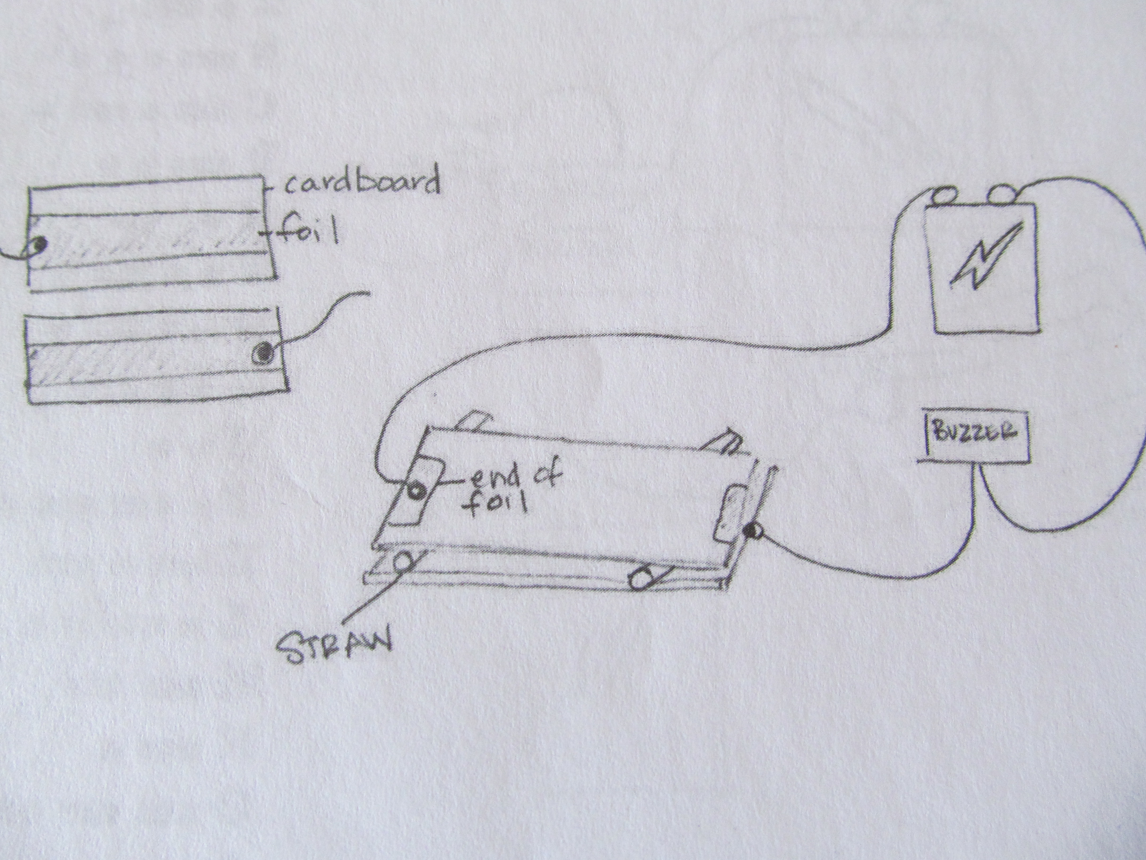

Question: “What are the different parts of your circuit? Talk in your groups.” “你的电路里有哪几部分？跟你的小组伙伴讨论。
- Have students share what they discussed in their groups. Refer to the puzzle pieces with the parts of a circuit.
Independent Practice: (25 minutes)
Explain: “You will now have the opportunity to use materials given to you, and perhaps other things in the classroom, to create your own circuit. Feel free to get creative and create your own alarm, machine, or game. You can take this alarm apart and use these materials as well as a few others I have for you on this table. Each group will have some pieces of paper you can use to draw a sketch of your circuit and what you want it to do. You can then come and get the materials you need and see if you can make it work! Use the sentence frames and language we have used over the past couple of days in your conversations. Be sure to take turns working with the materials and coming up with ideas.”
“你现在有机会用给你的材料，也许还有课堂上的其他的东西，创建自己的电路。你可以随意发挥创意，创建自己的警报器，机器，或游戏。你可以把这个警报器拆开，用这些材料，和其他桌子上我给你的材料。每个小组会有一张纸片，你可以在纸上画电路的草图，写下你要用它做什么。然后，你来拿你需要的材料，看看可不可以让你的电路工作！在你们交流的过程中，用我们学过的句子框架和语言。一定要轮流工作，和分享你的想法。“
- Pass out some blank sheets of paper to each group of students. On a table or desk in front of the class, provide additional materials such as: aluminum foil, cardboard, paper clips, plastic spoons, wood blocks, wire, sand paper, file folders, thumb tacks, construction paper. Show students the different materials they have the opportunity to use in their design. They must draw it out first before getting materials. They can come up and look at the materials if needed.
- Give students 15 minutes to work on their machines.
- Have each group present their machines and describe the different components and how they work. Have them identify whether or not their idea allowed for the light bulb to light up or the buzzer to go off.
- Pass out the electricity quiz for students to complete independently. Use this summative assessment to assess students’ mastery of language and content objectives for this unit.

Closing: (2 minutes)
Revisit the Objectives: Have the whole class reread the objectives. Have Partner 2 ask partner 1 what we learned today and have Partner 1 respond.

Real World Application: Encourage students to go home and experiment with materials they have at home. See if they can make their own machines with circuits. Warn students not to experiment with electrical sockets or anything that plugs in. This is dangerous. Give students an opportunity in a future class period to share what they createed at home.
Assessment:
Observe students’ conversations during the guided practice to assess their mastery of the language objective.
Observe students working together during independent practice to assess their mastery of the content objective.
Collect their quizzes as a summative assessment of the unit’s language and content objectives.
Extra Ideas:

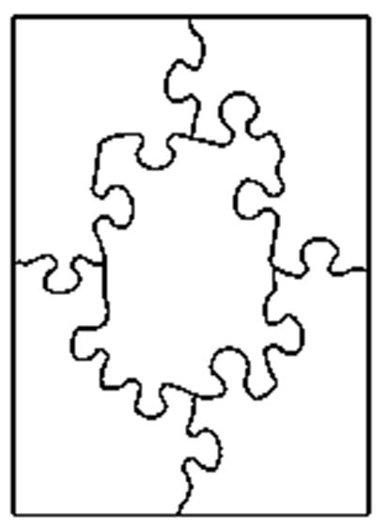
power source电源
Control控制

Path路径

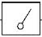
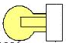

Indicator指标
Load负载

Name姓名 ____________________________________ Date日期________________________________

- What are 2 examples of static electricity in everyday life?在日常生活中有什么静电的例子？
_____________________________________________________________________________________________________________
_____________________________________________________________________________________________________________

2. Give an example of static electricity attracting an object. 举一个静电吸引物体的例子。
_______________________________________________________________________________________________________________
_______________________________________________________________________________________________________________

3. Give an example of two objects repelling each other because of static electricity. 举一个两个物体因为静电相互排斥的例子。
________________________________________________________________________________________________________________
________________________________________________________________________________________________________________

4. What role does static electricity play in lightning?在闪电中，静电扮演什么角色？/有什么作用？
_______________________________________________________________________________________________________________
_______________________________________________________________________________________________________________

5. What are the 3 critical parts of an electrical circuit? 电路的三个组成部分是什么？
________________________________________________________________________________________________________________
________________________________________________________________________________________________________________

6. What are 2 objects that can work in a circuit as conductors?在电路中可以当导体的两个物体是什么？
________________________________________________________________________________________________________________
________________________________________________________________________________________________________________

7. What properties do objects have that work as conductors?可以作为导体的物体有什么属性？
________________________________________________________________________________________________________________
________________________________________________________________________________________________________________

8. What are 2 objects that can prevent the flow of electricity as insulators?可以作为绝缘体，阻止电的流动的物体是什么？
________________________________________________________________________________________________________________
________________________________________________________________________________________________________________

9. Draw and label the components of a complete electrical circuit? (5 components)画一个闭合电路。并标记它的5个部分。

10. Describe a working electrical circuit—what were its components and how did they work together? (think of a specific machine or circuit you built) 描述一个正常工作的电路---它由哪几部分组成？它们如何一起工作？ （想想你连接的一个特定的机器或电路）_____________________________________________
________________________________________________________________________________________________________________
________________________________________________________________________________________________________________

