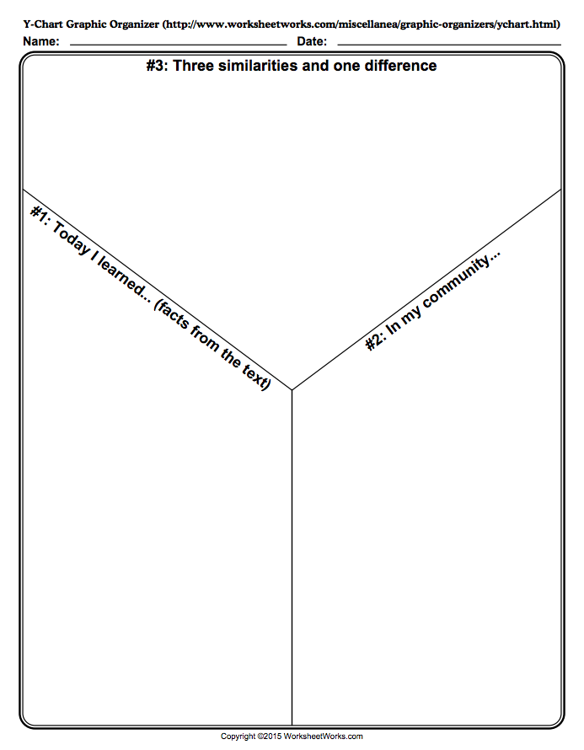

Nombre: ___________________________________________________ Clase: _____________

