Grade 5 | Lesson:  Landforms Part 7 |  | Reference to English Interconnections Lesson:  No Reference to Interconnections
Science Standard(s): Standard 2 Objective 1 and 2
Content Objective(s): |  | Language Objective(s):
Students will be able to create a landform using clay, categorize it based on how it was created, and explain how long it takes to form by creating a poster to display this information independently.  I can make my favorite landform using clay, place it in a category based on how it was created, and explain how long it can take to form by creating a poster to display this information independently.  能用粘土独立制作自己喜欢的地貌并贴上标签说明它形成的原因、时间并将其归类。 |  | Students will be able to explain how different landforms are created and how long they take to create by participating in a categorizing activity with a partner.  I can explain how different landforms are created and how long they can take to create play playing a categorizing game with a partner.  能够说明不同的地貌是如何形成的以及它们形成的时间并能和伙伴一起将其归类。
Essential Questions:  How is the Earth’s surface changing over time?  地球表面是如何随着时间的变化而变化的？ |  | Required Academic Vocabulary for Word Wall:  Listen: landform, erosion, weathering, deposition, earthquake, volcano, uplift, categorize  听：地貌，侵蚀，风化，沉积，地震，火山，隆起，分类  Speak: erosion, weathering, deposition, earthquake, volcano, uplift, cliffs, lake, arch, delta, butte, mesa, canyon, cave, valley, mountains, fault scarp  说：侵蚀，风化，沉积，地震，火山，隆起，悬崖，湖泊，拱，三角洲，山丘，平顶山，峡谷，岩洞，山谷，山脉，断层崖  Read: erosion, weathering, deposition, earthquake, volcano, uplift, cliffs, lake, arch, delta, butte, mesa, canyon, cave, valley, mountains, fault scarp, crater, island  读：侵蚀，风化，沉积，地震，火山，隆起，悬崖，湖泊，拱，三角洲，山丘，平顶山，峡谷，洞穴，山谷，山脉，断层崖，火山口，岛屿  Write: erosion, weathering, deposition, earthquake, volcano, uplift, cliffs, lake, arch, delta, butte, mesa, canyon, cave, valley, mountains, fault scarp, crater, island  写：侵蚀，风化，沉积，地震，火山，隆起，悬崖，湖泊，拱，三角洲，山丘，平顶山，峡谷，洞穴，山谷，山脉，断层崖，火山口，岛屿  Sentence Frames:  My favorite landform is a __________ because ________.  我最喜欢的地貌是__________ 是因为__________  How is a ________ created?  __________是怎么形成的？  A _________ is created by __________ because __________.  _____________ 是因为_____________由 _____________形成的。  How long does it take to create a __________?  __________的形成需要多久的时间？  It can take thousands of years to create a ____________.  __________的形成要花成千上万年的时间。  A ______________ can be created quickly.  __________能很快形成。  A _____________ can be created quickly or it can take thousands of years to create.  __________能够很快形成或是花成千上万年的时间。
Materials:  - Pictures of landforms from past lessons  - Heading cards  - Landform picture cards  - Posters  - Clay  - Steps to Poster Project |  | Additional Lesson Vocabulary:  Thousands of years, quickly, create  成千上万年，很快，形成
Lesson: |  |  |  | Instructional Time: 40 Minutes
Opening: (4 minutes)
- Post pictures of the different landforms you have talked about during this unit on the board.
T: “We’ve been learning so much about different landforms and how they’re created by weathering, erosion, deposition, volcanoes, earthquakes and upflift. Some landforms are created quickly, while others take thousands of years. I want everyone to think of their favorite landform we’ve learned about so far. Maybe you have more than one favorite. Pick just one and think of it right now.”
老师：“我们已经学习了很多不同的地貌已经它们是怎样由风化，侵蚀，沉积，火山，地震已经板块隆起形成的。有些地貌能够很快就形成，而有些却需要成千上万年。大家考虑一下自己最喜欢的地貌，可能会不止一种，但请大家现在只选择一种”
- Give students 30 seconds to think of a favorite.
T: “When I say ‘Go’ turn to your partner and tell them your favorite landform and explain why it is your favorite. Use the sentence frame to make a complete sentence, ‘My favorite landform is a ___________ because __________.’” Write the sentence frame on the board or on a poster. “Partner 1 will go first and Partner 2 will follow. Ready, Go!”
老师：“我说开始时大家就告诉你的伙伴你最喜欢的地貌以及原因。用这个句式来造句：我最喜欢的地貌是___________因为___________”
S1: My favorite landform is a ___________ because ____________.
学生：我最喜欢的地貌是___________因为___________”

S2: My favorite landform is a ___________ because ____________.
学生：我最喜欢的地貌是___________因为___________”

T: “I heard a lot of different favorites and I’m excited to hear about all of your favorites today. We’re going to make our favorite landform out of clay and collect information about your favorite landform on a poster that you’ll use to share with the class. Let’s take a look at our learning objective today.” Point to the student objective ‘I can make my favorite landform using clay, place it in a category based on how it was created, and explain how long it can take to form by creating a poster to display this information independently.’
老师：“我听到很多你们喜欢的地貌我也很高兴听到大家说出自己喜欢的地貌。现在我们就要用粘土来制作大家喜欢的地貌，并且用标签说明这种地貌的特征并和全班同学分享。我们一起来看看今天的学习任务。能用粘土独立制作自己喜欢的地貌并贴上标签说明它形成的原因、时间并将其归类。”
T: “Partner 2, when I say “go” you will ask your partner, ‘What are we going to do today?’” Write the question on the board. “Partner 1, you will read the objective on the board.” Point to the objective. “Then Partner 1, you will ask, ‘What is one thing we will learn today and how will we know we learned it?’” Write the question on the board. “Partner 2 will respond to the question by explaining one thing the class will learn today and how they will know they learned it.”
老师：“伙伴2，当我说“开始”时，你们问伙伴1：今天我们的学习任务是什么？”把问题写在黑板上。“伙伴1，你们要仔细阅读写在黑板上的学习任务，并且回答伙伴2的问题，然后伙伴1问伙伴2“我们今天要学的其中一项内容是什么以及我们怎样知道已经掌握了所学内容？””把问题写在黑板上。“伙伴2回答今天我们要学习的内容以及如何知道我们都掌握了。”
- Give the class 1-2 minutes.
S2: What are we going to do today?
学生:今天我们的学习任务是什么？
S1: We are going to create a landform, categorize it based on how it was created, explain how long it takes to form by making a poster.
学生：我们要制作一种地貌根据它形成的原因将其归类并用标签说明它形成的时间。
S1: What is one thing we will learn today and how will we know we learned it?
学生：我们今天要学的其中一项内容是什么以及我们怎样知道已经掌握了所学内容？

S2: We are going to make our own landform using clay and explain how it was created and how long it took to create by making a poster to present the information. We’ll know we learned it by making our poster independently.
学生：能用粘土独立制作自己喜欢的地貌并贴上标签说明它形成的原因、时间并将其归类。
Introduction to New Material (Direct Instruction): (8 minutes)
T: “We have learned how these landforms are created.” Refer to the pictures of the landforms on the board. “Some are created by Weathering, Erosion and/or Deposition. Others are created by Volcanoes, Earthquakes or Uplift. We’re going to review how these landforms were created and categorize them based on how they were created. You will find that some landforms were created in more than one way. Let’s look at Mountains for example. Think about one way that mountains have been formed and why. When I say ‘Go’ Turn to your partner and explain one way that mountains are formed. Think.”
老师：“我们已经知道一些地貌是如何形成的，有些是由于风化、侵蚀和沉积形成的，有些是由火山，地震和板块隆起形成的。我们要复习这些地貌的形成原因并根据它们形成原因将它们归类。你们会发现有些地貌是由于多种原因形成的。以山脉为例，大家想一下山脉形成的而一个原因，当我说开始时，大家和你们的伙伴讨论山脉是如何形成的。”
- Give the class 30 seconds to think
T: “Okay, turn to your partner and tell them one way mountains are formed—from Weathering, Erosion and/or Deposition, from Volcanoes, from Earthquakes or from Uplift. You will use the sentence frame, ‘_______________ are created by _______________ because _________________________.” Write the sentence frame on the board or on a poster. “Partner 2 will go first and then Partner 1 will follow. Go!”
老师：“好的，现在就告诉你的伙伴山脉是由以下原因中的哪一种形成的—风化、侵蚀、沉积、火山、地震和板块隆起。你们用这个句式回答：_____________ 是因为_____________由 _____________形成的。”
S2: A mountain is created by ___________________ because _________________________.
学生：山脉是因为_____________由 _____________形成的。
S1: A mountain is created by ____________________ because ________________________.
学生：山脉是因为_____________由 _____________形成的。
T: “Great! Raise your hands if you and your partner came up with different ways that mountains are created.”
Students raise their hands.
老师：”很好，如果你和你的伙伴有不同的意见请举手。”
T: “We have learned that a mountain can be a volcanic mountain created by a volcano or it can be created by uplift. Mountains can also be created by earthquakes. Valleys are also created in different ways. Think about one way that valleys have been formed and why. When I say ‘Go’ Turn to your partner and explain one way that valleys are formed. Think.”
老师：“我们已经知道火山山脉是由火山形成的或是由地球板块隆起形成的。地震也能形成山脉。山谷也有许多的形成原因。大家想出一种原因，但我说开始时大家就和伙伴讨论这个原因。”
- Give the class 30 seconds to think
T: “Okay, turn to your partner and tell them one way valleys are formed—from Weathering, Erosion and/or Deposition, from Volcanoes, from Earthquakes or from Uplift. You will use the sentence frame, ‘_______________ are created by _______________ because _________________________.” Write the sentence frame on the board or on a poster. “Partner 1 will go first and then Partner 2 will follow. Go!”
老师：“好的，现在就告诉你的伙伴山脉是由以下原因中的哪一种形成的—风化、侵蚀、沉积、火山、地震和板块隆起。你们用这个句式回答：_____________ 是因为_____________由 _____________形成的。伙伴1先说然后伙伴2说。”
S1: A valley is created by ___________________ because _________________________.
学生：山谷是因为_____________由 _____________形成的。
S2: A valley is created by ____________________ because ________________________.
学生：山谷是因为_____________由 _____________形成的。

T: “Great! Raise your hands if you and your partner came up with different ways that valleys are created.”
Students raise their hands.
老师：”很好，如果你和你的伙伴有不同的意见请举手。”

T: “Valleys can be created by flowing water and erosion such as in a V-shaped valley. U-shaped valleys are created by glaciers and occur through weathering and erosion. Valleys can also be a result of earthquakes. So some of our landforms can go in more than one category. We’re going to categorize our landforms under the categories ‘Weathering, Erosion and/or Deposition,’ ‘Volcanoes,’ ‘Earthquakes,’ and ‘Uplift’. If a particular landform fits under two categories, I will place it under one and explain why it fits there, then I can move it under another category and explain why it fits there.”
老师：“流水和侵蚀能够形成山谷如V形山谷。U形山谷是由冰川作用的风化和侵蚀形成的。地震也能形成山谷。所以很多地貌可以有不同原因形成。现在我们根据地貌形成的原因来将它们成两类：风化、侵蚀和沉积是一类，地震一类，火山一类，板块隆起一类。如果一种地貌符合两种类型，先将它们归到一类并解释原因，然后再归类到其它一类并解释原因。”
T: “There is something else I want us to notice. Not only are landforms created in different ways, it takes different amounts of time to create different landforms. Let’s look at landforms created by weathering, erosion and deposition. Think, does it take thousands of years to create these landforms, or are they created quickly? Turn to your partner and tell them what you think. Go!”
老师：“大家还要注意的是：地貌可以由多种原因构成，它们形成的时间也有不同。我们来看看由风化、侵蚀和沉积形成的地貌，想一想它们需要成千上万年形成还是很快就能形成，大家和伙伴讨论一下，开始”
S: It takes thousands of years to create these landforms.
学生：需要成千上万年的时间。
T: “Okay class, does it take thousands of years or does it happen quickly?”
老师：好的，大家说它们需要成千上万年形成还是很快就能形成？
S: It takes thousands of years.
学生：需要成千上万年的时间。
T: “Very good. It takes a long time for weathering, erosion and deposition to make these landforms. Let’s look at the landforms created by Volcanoes. Does it take thousands of years to create these landforms, or are they created quickly? Turn to your partner and tell them what you think. Go!”
老师：“很好。风化、侵蚀和沉积确实需要很长时间才能形成这些地貌。让我们来看看由火山形成的地貌，想一想它们需要成千上万年形成还是很快就能形成，大家和伙伴讨论一下，开始”
S: For some it takes thousands of years and for others it can happen quickly.
学生：有些需要成千上万年的时间，有些能很快形成。

T: “I could see that this one was more difficult to answer. And you’re all right. For some of these landforms it can take thousands of years, and for others such as the crater it can happen quickly. Let’s look at landforms created by Earthquakes. Does it take thousands of years to create these landforms, or are they created quickly? Turn to your partner and tell them what you think. Go!”
老师：“这个确实很难回答。你们是对的。有些地貌需要成千上万年的时间，而有些能很快形成。让我们来看看由地震形成的地貌，想一想它们需要成千上万年形成还是很快就能形成，大家和伙伴讨论一下，开始”

S: For some it takes thousands of years and for others it can happen quickly.
学生：有些需要成千上万年的时间，有些能很快形成。
T: “I could see that this one was more difficult to answer. And you’re all right again. For some of these landforms it can take thousands of years such as with mountains and valleys, and for others such as the fault scarp it can happen quickly. Let’s look at landforms created by Uplift. Does it take thousands of years to create these landforms, or are they created quickly? Turn to your partner and tell them what you think. Go!”
老师：“这个确实很难回答。你们是对的。有些地貌需要成千上万年的时间如山脉和山谷，而有些能很快形成如断层崖。让我们来看看由地球板块隆起形成的地貌，想一想它们需要成千上万年形成还是很快就能形成，大家和伙伴讨论一下，开始”
S: It takes thousands of years.
学生：需要成千上万年的时间。

T: “This one seemed easier to answer. Yes, uplift takes thousands of years.”
老师：这个很容易回答，确实需要成千上万年的时间。

Guided Practice: (10 minutes)
T: “Now it is your turn to practice categorizing. You’re going to receive a set of cards with pictures of landforms and their names. You will also receive 4 headings: Weathering, Erosion and/or Deposition, Earthquakes, Volcanoes and Uplift. You’ll select a card and your partner will ask you how that landform is created. You will identify how it is formed and place the card under a particular heading. Identify more than one way it is formed, if that is the case and move it under a second heading if it applies. Your partner will then ask how long it takes to create that landform. Then you’ll state if it’s created quickly or takes thousands of years to create. Then it will be your partner’s turn to draw a card. You’ll be using two sets of sentence frames. The partner asking the questions will use, ‘How is a ________ created?’ and ‘How long does to take to create a ____________.’” Point to the sentence frames. “The partner answering the questions will use, ‘A _________________________ is created by _______________ because ______________________. And then you’ll use ’It can take thousands of years to create a ________.’ or ‘A _______ can be created quickly.’ or ‘A _____________ can be created quickly or it can take thousands of years to create.’” Point to the sentence frames.
老师：“现在我们来联系归类。大家将会拿到一组标有名字的不同地貌的图片。你们也会拿到标有风化、侵蚀、沉积、地震、火山和板块隆起的种类卡片。现在选一张图片，你的伙伴会问你这样的地貌是如何形成的，你要先说明这个地貌是如何形成的并把他们归到特定的种类下。如果你发现地貌有不同的原因构成，你可以把这个地貌移到第二个类别下面。你的伙伴会问你这样的地貌要多久能形成。你回答是很快就能形成还是需要成千上万年的时间。然后就轮到你的伙伴画画。你将用到下面的两个句式，伙伴问问题的句式：__________是怎样形成的？__________的形成需要多久的时间？ 伙伴回答问题的句式是_____________ 是因为_____________由 _____________形成的”然后你回答：__________的形成需要成千上万年的时间，或者__________很快就能形成。或者是__________既能很快就形成也能花费成千上万年的时间形成。

Use the Modeling Cycle:

Teacher Does:
- Use a puppet, stuffed animal or imaginary partner to demonstrate.
T1: “I am Partner 1. I am going to select a card from the stack. I picked a lake.”
老师：我是伙伴1，我要从这堆卡片中选一张，我选了湖泊。
T2: “As Partner 2, I will ask the question, ‘How is a lake created?’” Point to the sentence frame.
老师：我是伙伴2，我要问：湖泊是如何形成的？
T1: “Partner 1 will then use the sentence frame to tell Partner 2 how it was created. ‘A lake is created by weathering and erosion because glaciers can melt which weathers and erodes the land and water collects making a lake.” Point to the sentence frame.
老师：伙伴1用句式告诉伙伴2湖泊是如何形成的：湖泊是由于冰川引起的风化和侵蚀形成的，冰川融化陆地之后水聚集在上面从而形成湖泊。
- Place the picture under the heading “Weathering, Erosion and/or Deposition”.
T1: “A lake is also created by uplift, because the plates of the earth can lift and create mountains, which allows water to collect at the base of mountains in a bowl-shaped depression.”
老师：地球板块隆起也能形成湖泊，因为地球板块隆起时形成山脉，而水会在山脉边缘的碗形处的洼地沉积从而形成湖泊。
- Move the picture card under the heading “Uplift”.
T1: “A lake is also created by earthquakes, because earthquakes can create mountains and water can run off the mountains and collect in a bowl-shaped depression making a lake.”
老师：“地震能够形成湖泊，因为地震能够形成山脉，而水会在山脉边缘的碗形处的洼地沉积从而形成湖泊。”
T2: “Partner 2 will then ask the question, ‘How long does it take to create a lake?’”
老师：“伙伴2接着就问：要多久才能形成湖泊？”
T1: “Partner 1 will then answer the question by using the sentence frame and answering, ‘It can take thousands of years to create a lake.’ It is then Partner 2’s turn to select a card and answer questions, and Partner 1’s turn to ask the questions.”
老师：“伙伴1用学过的句式回答：需要成千上万年形成湖泊。接下来就是伙伴2选卡片回答问题，伙伴1问问题了。”
Teacher Models with a Student:
- Select a student to come help you model.
T: “I will be Partner 2 and you can be Partner 1. Select a card from the stack.”
老师：“我是伙伴2，你是伙伴1，现在选一张卡片。”
The student selects a card from the stack.
- Show the class the card the student selected.
T: “As Partner 2, I will ask the question, ‘How is a _____ created?’” Point to the sentence frame.
老师：“我是伙伴2，我就问：_____是如何形成的？”
S: A _________ is created by _____________ because ______________.
学生：_____________ 是因为_____________由 _____________形成的。
- Point to the sentence frame. Help the student place the picture under the correct category. If there is another way it is created, prompt the student to give another response and move the card.
T: “Partner 2 will then ask the question, ‘How long does it take to create a __________?’”
老师：“伙伴2就问：_____的形成需要多长时间？”

S: It takes thousands of years to create a _______. (Or A _________ can be created quickly. Or A ______ can be created quickly or it can take thousands of years.)
学生：__________的形成需要成千上万年的时间，或者__________很快就能形成。或者是__________既能很快就形成也能花费成千上万年的时间形成。
T: “It is then Partner 2’s turn to select a card and answer questions, and Partner 1’s turn to ask the questions.”
老师：“接下来就是伙伴2选卡片回答问题，伙伴1问问题了。”
Two Students Model:
- Select two students to come model.
T: “Decide who will be Partner 1 and who will be Partner 2.”
老师：“大家现在决定谁做伙伴1，谁做伙伴2.”
The students decide who will be Partner 1 and 2.
Partner 1 selects a card from the stack.
- Show the class the card the student selected.
S2: How is a _____ created?
学生：_____是如何形成的？
S1: A _________ is created by _____________ because ______________.
学生：_____________ 是因为_____________由 _____________形成的。

Partner 1 places the picture under the correct category.
- If there is another way it is created, prompt the student to give another response and move the card.
S2: How long does it take to create a __________?
学生：_____的形成需要多长时间？”
S1: It takes thousands of years to create a _______. (Or A _________ can be created quickly. Or A ______ can be created quickly or it can take thousands of years.)
学生：__________的形成需要成千上万年的时间，或者__________很快就能形成。或者是__________既能很快就形成也能花费成千上万年的时间形成。

T: “It is then Partner 2’s turn to select a card and answer questions, and Partner 1’s turn to ask the questions.”
老师：“接下来就是伙伴2选卡片回答问题，伙伴1问问题了。”

All Students Practice:
- Pass out the sets of cards to each partnership. Walk around and help students with their categorizing and their use of the sentence frames in their responses.
Independent Practice: (15 minutes)
T: “Excellent practice class! I can tell how much you have learned about landforms, how they were created, and how long they can take to create. Now is your chance to become an expert on ONE of these landforms. You will be selecting one landform that is one of your favorites. You will be making your favorite landform with clay and creating a poster about your landform. On your poster you will write the name of your landform, identify the categories it falls under such as Weathering, Erosion and/or Deposition, Earthquakes, Volcanoes or Uplift, and then identify how long it takes to create your landform. You will use the sentence frames on your poster. You and your partner will each be making your own posters, but it is important that you and your partner pick two different landforms. If you both have the same favorite, one of you could pick another favorite.”
老师：“非常好。大家已经学习了多种不同的地貌，它们是如何形成的以及它们需要多久能够形成。现在大家有机会成为一种地貌的专家。大家选一个你最喜欢的地貌，并用粘土建成一个模型用标签说明这个地貌的名称、种类（风化、侵蚀、沉积、地震、火山和板块隆起）以及它形成需要的时间。标签说明时用你们学习过的句式。你和你的伙伴每个人都有自己的标签，但是你们两个必须选择不同的地貌。如果你们喜欢的地貌一样，其中的一个必须要换成另外的地貌。”
- Post the list of the steps under the document camera or copy the steps onto the board.

Use the Modeling Cycle:

Teacher Does:
- Place a poster up on the board to model.
T: “I am going to imagine that my favorite landform is lake, like I used before. A lake is not really my favorite, so don’t feel like you all need to be like the teacher and make the lake your favorite. Try to select something different. I am going to make sure that my favorite landform is different than my partner’s favorite landform. I am going to write the title of my landform on my poster. Titles are usually bigger than the rest of the writing on your poster.” Refer to the steps.
老师：“现在假设我喜欢的地貌是湖泊。但湖泊并不是我最喜欢的地貌所以你们不用和老师一样选择湖泊作为你们喜欢的地貌。试着选别的地貌。我要保证我喜欢的地貌和我的伙伴喜欢的不一样。我会在我的标签上写上地貌的名称，这个名称的姿态一定要大于标签上其它的文字。”
- Write ‘Lake’ at the top of your poster in large, clean handwriting.
T: “Now I am going to make a lake with my clay.”
老师：现在我就用粘土建成一个湖泊的模型。
- Refer to the steps. Model for the students how you are creating a lake with your clay.
T: “Now I am going to identify the categories it falls under and why. I will write down my sentences I said earlier. I will use the sentence frames to write my sentences. Because there are many ways to create a lake, I will write three different sentences following the sentence frames. ‘A lake is created by weathering and erosion because glaciers can melt which weathers and erodes the land and water collects making a lake.’ ‘A lake is created by uplift, because the plates of the earth can lift and create mountains, which allows water to collect at the base of mountains in a bowl-shaped depression. ‘A lake is also created by earthquakes, because earthquakes can create mountains and water can run off the mountains and collect in a bowl-shaped depression making a lake.’”
老师：“现在我就要将它归类并且说明原因。我用我们学过的句式写下这些句子。因为有很多的原因可以形成湖泊所以我会用下面的句式写下三个句子来说湖泊形成原因：冰川引起的风化和侵蚀能够形成湖泊，冰川融化陆地之后水聚集在上面从而形成湖泊。地球板块隆起也能形成湖泊，因为地球板块隆起时形成山脉，而水会在山脉边缘的碗形处的洼地沉积从而形成湖泊。地震能够形成湖泊，因为地震能够形成山脉，而水会在山脉边缘的碗形处的洼地沉积从而形成湖泊。”
- Refer to the steps. Write the sentences on your poster in smaller, clean handwriting.
T: “I am going to leave some space between the sentences I wrote about how a lake is created and my next sentence. Now I am going to write how long a lake takes to form. A lake can take thousands of years to create.”
老师“我在这些句子中间留一些位置写上湖泊的形成需要多久的时间。湖泊的形成需要成千上万年的时间。”
- Refer to the steps. Write the sentence on your poster in smaller, clean handwriting.
T: “Now I can draw my landform and color it.”
老师：“现在我就画出湖泊并涂上颜色。”
- Refer to the steps. Draw a quick picture of your landform and begin to color it.
T: “Now my poster is complete! I will be using this poster next time to present about my landform to the class and to compare and contrast my landform with my partner’s landform.”
老师：“现在我的标签就完成了！下次我就要这个标签向全班同学来说明我的地貌，并和我伙伴的地貌进行对比。”

Teacher Models with a Student:
- Place a new poster up on the board and select a student to come up to model.
T: “What is your favorite landform?”
老师：“为什么这个是你最喜欢的地貌？”
Student states his/her favorite landform.
T: “You will make sure that your favorite landform is different than your partner’s. Now follow the steps. What are you going to do first?” Refer to the steps.
老师：“你必须保证你喜欢的和你伙伴的不一样，然后按照步骤做，你第一步要做什么？”
S: I am going to write the title of my landform on my poster.
学生：我要在标签上写下地貌的名称。
Student writes his/her title on the poster in large, clean handwriting.
T: “Now what are you going to do?” Refer to the steps.
老师：“现在要做什么呢”
S: I am going to make my landform with my clay.
学生：要用粘土做一个地貌的模型。
Student creates the landform with the clay.
T: “Now what are you going to do?” Refer to the steps.
老师：“现在要做什么呢”

S: I am going to identify the categories it falls under and why.
学生：要将它归类并说明原因。
T: “Go ahead and tell us out loud first. What categories does your landform fall under?”
老师：“大声告诉我们你的地貌属于哪一类的？”
Student identifies the category/categories the landform falls under.
T: “Great, now go ahead and write them down using the sentence frames.”
老师：”很好，接着用你们学过的句式把它们写下来。”
Student writes down the sentences using the sentence frames.
T: “Now what are you going to do?” Refer to the steps.
老师：“现在要做什么呢”

S: I am going to leave some space and then write how long my landform takes to form.
学生：留些空格写上这个地貌需要多长时间形成。
T” Go ahead and tell us out loud first. How long does it take for your landform to be created?”
老师：“大声告诉我们这个地貌需要多长时间形成。”
Student identifies how long it takes for the landform to be created.
T: “Great, now go ahead and write it down using the sentence frames.”
老师：很好，现在用我们学过的句式写下来。
Student writes down the sentence using the sentence frames.
T: “Now what are you going to do?” Refer to the steps.
老师：“现在要做什么呢”
S: I am going to draw my landform and color it.
学生：我要画下这个地貌并涂上颜色。
Student draws a quick picture of the landform and begins to color it.
T: “Now your poster is complete! You will be using this poster next time to present about your landform to the class and to compare and contrast your landform with your partner’s landform.”
老师：“现在你的标签就完成了！下次你就要这个标签向全班同学来说明你的地貌，并和你伙伴的地貌进行对比。”

All Students Practice:
- Pass out posters and clay to students. Also pass out markers to students if you choose to let them use markers. Review any procedures you may have established for marker use. Walk around and ensure students are following the steps and understanding what they are to do. Also ensure students are selecting a different landform from their partners.

Closing: (3 minutes)
T: “Excellent work today class! Let’s see if we met our learning objective. When I say, ‘Go’ I want you to turn to your partners and read the objective together in a quiet voice. Ready, Go!”
老师：“大家做的都很好！ 让我们看看我们是否完成了学习任务。我说开始，大家就和你的伙伴一起默读今天的学习任务，准备好了吗，开始！”
S: I can make my favorite landform using clay, place it in a category based on how it was created, and explain how long it can take to form by creating a poster to display this information independently.
学生：能用粘土独立制作自己喜欢的地貌并贴上标签说明它形成的原因、时间并将其归类。
- Use attention-getting signal.
T: “Great! Now, when I say, ‘Go’ I want Partner 2 to explain in your own words to Partner 1 what you learned today and how you know you learned it. Ready, Go!”
老师：“很好，我说开始，伙伴1用你自己的话告诉伙伴2今天你学到了什么，如何知道你已经掌握了这个知识。”
S2: We made our own landform using clay and explained how it was created and how long it took to create by making a poster to present the information. We know we learned it because we made a poster independently.
学生：能用粘土独立制作自己喜欢的地貌并贴上标签说明它形成的原因、时间并将其归类。

T: “Great! Now, when I say, ‘Go’ I want Partner 1 to explain in your own words to Partner 2 what you learned today and how you know you learned it. Ready, Go!”
老师：“很好，我说开始，伙伴1用你自己的话告诉伙伴2今天你学到了什么，如何知道你已经掌握了这个知识。”

S1: We made our own landform using clay and explained how it was created and how long it took to create by making a poster to present the information. We know we learned it because we made a poster independently.
学生：能用粘土独立制作自己喜欢的地貌并贴上标签说明它形成的原因、时间并将其归类。

T: “Let’s hear what a couple of you have to say.”
老师：我们来听听你们需要说的话。
- Call on a couple of students to share what they learned and how they know they learned it.
T: “Excellent. It is clear to me that we met our objective today. In our next science lesson, you are going to share your posters with the class and present your landform. You will also be working with a partner to compare and contrast your landform with a partner’s landform.”
老师：很好。我知道了大家都完成了今天的学习任务。下节课，你们就要向全班同学展示你们的地貌并用标签来说明这个地貌的特征。你们还要将你选的地貌和你伙伴的地貌进行对比。
Assessment:
Observe students in the guided practice and watch for language production and errors in reasoning..
Observe clay models and posters.

Extra Ideas:
- Instead of making posters, you could take the students to the computer lab and have them create a digital document or a powerpoint presenting their material.

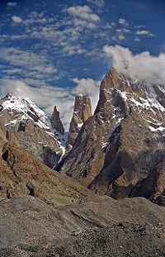  Cliff  悬崖 | Butte  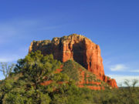  山丘
Arch 拱  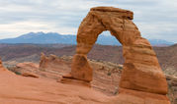 | 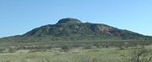  Mesa 平顶山
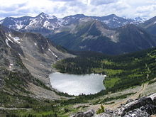  Lake湖泊 | 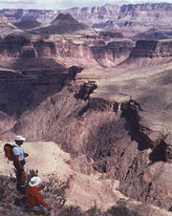  Canyon  峡谷
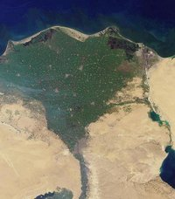  Delta  三角洲 | 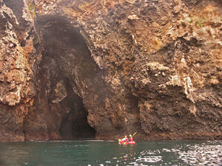  Cave  岩洞

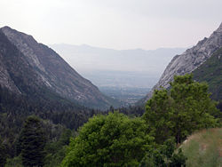  Valley 峡谷 | 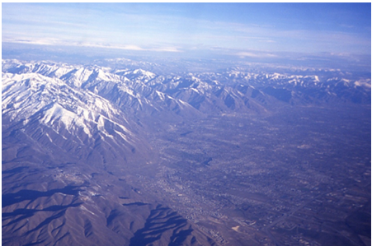  Mountains 山脉
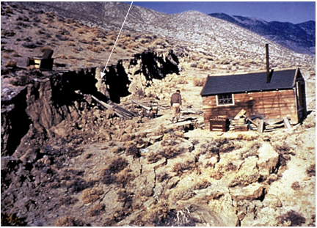  Fault Scarp 断层崖 | Crater 火山口  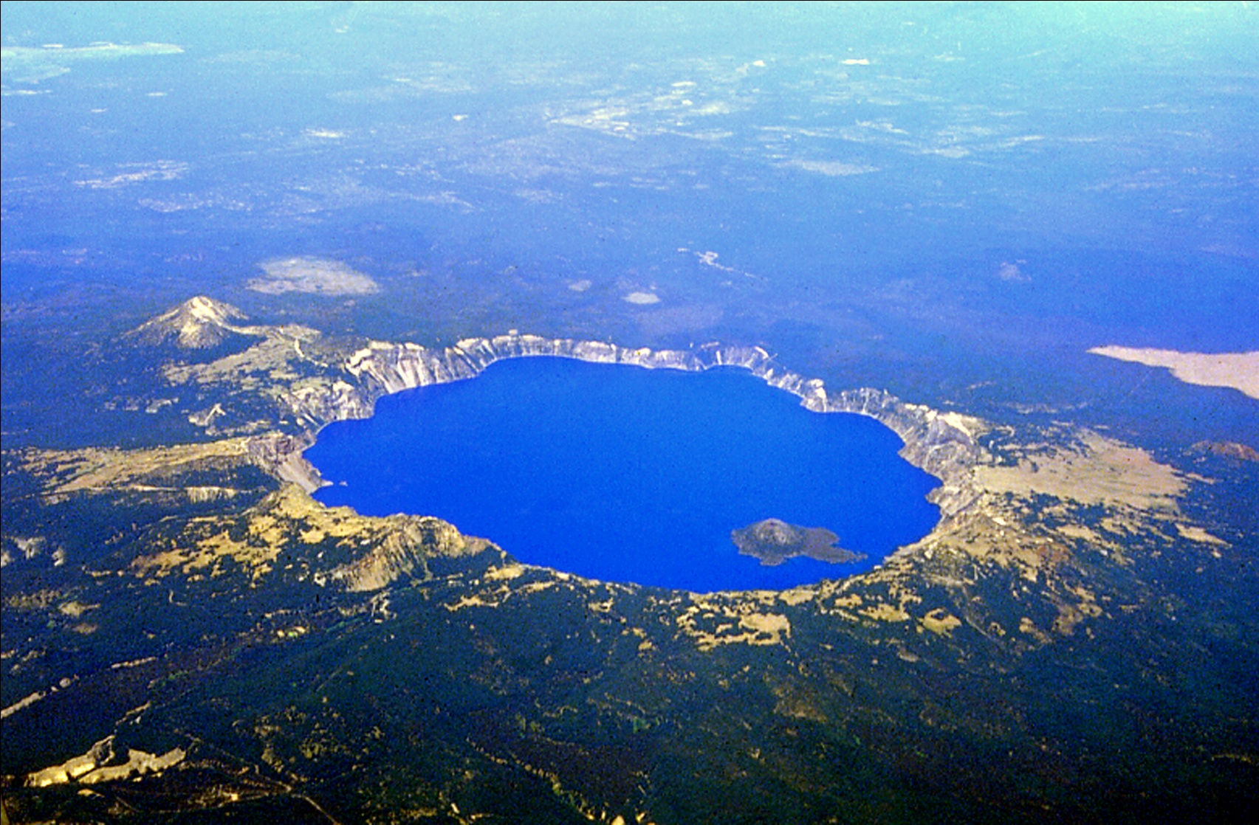
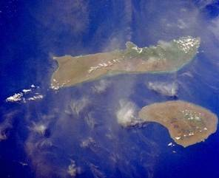
Island 岛屿

Weathering/Erosion/  Deposition  风化、侵蚀、沉积 | Earthquakes  地震
Volcanoes  火山 | Uplift  隆起

Steps to Poster Project

- Select a favorite landform. Make sure your favorite landform is different from your partner’s.
- Write the name of your landform as a title on your poster. Handwriting should be large and clean.
- Make your landform with the clay.
- Categorize your landform and write it on your poster using the sentence frame: A ____ is created by ____ because _________. Categorize your landform more than once when applicable. Handwriting should be small and clean.
- Explain how long it can take to create your landform using the sentence frame: It can take thousands of years to create a ____________, A ______________ can be created quickly, OR A _____________ can be created quickly or it can take thousands of years to create. Handwriting should be small and clean.
- Draw a picture of your landform on your poster and color it.

小组活动步骤
- 选一个你喜欢的地貌，必须要和你伙伴的不同。
- 在标签上写上地貌的名称，字体要大而清楚。
- 用粘土做一个地貌模型。
- 将地貌归类，并在标签上用学过的句式写：_____________ 是因为_____________由 _____________形成的。如果地貌形成的原因有多种，可以将其归到不同的类别。字体要比名称小、清楚。
- 用这个句式：__________的形成需要成千上万年的时间，或者__________很快就能形成。或者是__________既能很快就形成也能花费成千上万年的时间形成。来说明这个地貌需要多长时间形成。字体要比名称小、清楚。
- 在标签上画出这个地貌并涂上颜色。

