Grade 5 | Lesson:  Landforms Part 5  Volcanoes |  | Reference to English Interconnections Lesson  No Reference to Interconnections
Science Standard(s): Standard 2 Objective 2
Content Objective(s): |  | Language Objective(s):
Students will give examples of different landforms that are formed by volcanoes, identify three types of volcanoes and describe how technology is used to predict volcanic eruptions by creating books about volcanoes independently.  I can give examples of different landforms that are formed by volcanoes, state three types of volcanoes, and describe how technology is used to predict volcanic activity by making a volcano book by myself.  能够举例说出三种不同的由火山喷发而形成的地貌，说明三种不同火山，并通过独立制作火山图册来说明如何运用科技来预测火山喷发。 |  | Students will be able to define a volcano, describe the three types of volcanoes, explain how volcanoes create different landforms and describe how technology can be used to predict a volcanic eruption by participating in an activity with a partner.  I can explain what a volcano is, describe three types of volcanoes, explain how volcanoes create different landforms, and explain how technology can predict volcanic eruptions by participating in an activity with a partner.  能够说明火山是什么，描述有哪三种火山，解释火山喷发如何形成不同的地貌并且能在小组活动中给伙伴解释如何运用科技来预测火山喷发。
Essential Questions:  How is the Earth’s surface changing over time?  地球表面是如何随着时间的变化而变化的？ |  | Required Academic Vocabulary for Word Wall:  Listen: Volcano, eruption, fault, magma, seismograph, mountains, cinder cone, shield, composite, craters, islands, tiltmeter  听：火山、喷发、地震带、岩浆、地震仪、山脉、火山锥、地盾、复合物、火山口、岛屿、斜度仪  Speak: Volcano, eruption, mountains, magma, seismograph, mountains, cinder cone, shield, composite, craters, islands, tiltmeter  说：火山、喷发、地震带、岩浆、地震仪、山脉、锥形火山、地盾、复合物、火山口、岛屿、斜度仪  Read: Volcano, volcanic eruptions  读：火山、火山喷发  Write: Volcano, eruption, mountains, magma, seismograph, mountains, cinder cone, shield, composite, craters, islands, tiltmeter  写：火山、喷发、地震带、岩浆、地震仪、山脉、火山渣锥、地盾、复合物、火山口、岛屿、斜度仪  Sentence Frames:  A volcano is _________  火山是_________  Volcanoes can create _________ by __________.  火山是由_________形成的。  One type of volcano is ________. It ___________.  火山的一种是_________  Another type of volcano is ________. It ___________.  火山的另外一种是_________  Scientists can predict volcanic eruptions by _______.  科学家能够通过_________预测火山喷发。
Materials:  - Vocabulary cards  - Slips of Paper with questions and sentence strips (one set per partnership)  - Two 5 oz paper cups (1 pair per partnership)  - Straw (1 per partnership)  - Two books or boxes (1 pair per partnership)  - Whiteboards, markers and erasers (one set per partnership)  - Volcano book pages  - Scissors  - Crayons  - Stapler |  | Additional Lesson Vocabulary:  plates, scientists, pressure  板材、科学家、压力
Lesson: |  |  |  | Instructional Time: 55 minutes

Opening: (6 minutes)
T: “Raise your hand if you have ever seen a real volcano. I’m sure it wasn’t erupting, but perhaps many of you have seen an actual volcano.”
老师：“见过真正火山的同学请举手。大家见过的一定不是火山喷发但一定是真正的火山。”
Students raise their hands.
T: “Some of us might know a little about volcanoes, and some of us might know a lot! Let’s look at what we know and what we want to know about volcanoes.”
老师：“我们有些同学可能知道一点有关火山的只是，有些可能知道很多！让我们来看看大家都知道什么以及我们想知道什么。”
- Post KWL chart.
T: “Turn to your partners and share one thing you each know about volcanoes.”
老师：“大家和你们的伙伴分享你所知道的有关火山的知识。”
Students share with their partners.
T: “Now, raise your hands and share what you talked about and we’ll write it on our chart. If your ideas were already mentioned, put your hands down.”
老师：“现在大家举手告诉我们你们讨论的内容我写在纸上，如果你所知道的已经在纸上了请放下手。”
- Call on students and write down the things they know about volcanoes on the KWL chart.
T: “Now everyone, take a minute and think… what do you want to know about volcanoes?”
老师：“好的现在给大家一分钟时间想一下你们想知道有关火山的哪些知识？”
- Give students 15-30 seconds to think.
T: “Turn to your partners and share one thing you each want to know about volcanoes that we don’t already know.”
老师：“大家和你们的伙伴们讨论你们每人想要知道的知识，而这些知识必须是我们不知道的。”
Students share with their partners.
T: “Now, raise your hands and share what you talked about and we’ll write it on our chart. If your ideas were already mentioned, put your hands down.”
老师：“现在大家举手告诉我们你们讨论的内容我写在纸上，如果你所知道的已经在纸上了请放下手。”
- Call on students and write down the things they want to know about volcanoes on the KWL chart. Make sure students mention the key ideas of the lesson- landforms created by volcanoes, types of volcanoes, how technology can predict volcanic eruptions, etc.
T: “Let’s look at our objective for today to see what we are going to learn. Class, read it with me!”
老师：“现在让我们看看今天我们的学习任务，大家一起和我读”

S: I can give examples of different landforms that are formed by volcanoes, state three types of volcanoes, and describe how technology is used to predict volcanic activity by making a volcano book by myself.
学生：能够举例说出三种不同的由火山喷发而形成的地貌，说明三种不同火山，并通过独立制作火山图片来说明如何运用科技来预测火山喷发。

T: “Great. It looks like we’re going to learn a couple of things today. Partner 1, turn to Partner 2 and identify one thing we are going to learn and be able to do today. Go.”
老师：“很好。今天我们要学很多东西呢。伙伴1向你的伙伴2解释我们今天要学习一项任务，开始。”
S1: We are going to say the names of different landforms created by volcanoes.
学生：我们要学习由火山形成的不同地貌的名称。

T: “Good. Partner 2, turn to Partner 1 and identify another thing we’re going to learn and be able to do today. Go.”
老师：“很好。伙伴2向你的伙伴1解释我们今天要学习的另一项任务，开始。”

S2: We are going to explain how technology is used to predict the eruption of volcanoes.
学生： 我们要学习科技是如何用来预测火山喷发的。

T: “Excellent. Now talk in your partnerships about how we will know that we learned our objective, and raise your hands when you agree on an answer. Go.”
老师：“很好。现在和你的伙伴讨论我们如何知道已经达到学习任务，知道答案的请举手。”

S: We will make volcano books independently.
学生：我们能够独立制作火山图册。
- Select one partnership to share their response with the class.
T: “Great. Let’s get started!”
老师：“很好，让我们现在就开始。”

- Introduction to New Material (Direct Instruction): (12 minutes)
T: “Looking at what we know about volcanoes, we know volcanoes often erupt, and magma rises under the earth’s surface. And it seems that our class wants to know what exactly is a volcano, how volcanoes are made, what landforms are created by volcanoes, different types of volcanoes and how we predict the eruption of volcanoes.”
老师：“现在看看我们都知道有关火山的哪些知识：火山会经常喷发，岩浆会喷射出地表。大家都想知道什么是火山，火山是如何形成的，火山能够形成哪些地貌，火山的种类以及人类如何预测火山喷发。”
- Refer to the KWL chart.
T: “Given what we know about volcanoes, let’s see what type of definitions you can come up with for a volcano. When I say, ‘Go’, turn to your partners and come up with a definition of a volcano. Let’s see what you come up with. Ready, go!”
老师：“根据我们知道的火山的知识，我们来试着给火山下个定义。我说开始时，大家就和伙伴一起讨论火山的定义，看看大家会有怎样的结论，开始。”
Students talk with partners and come up with definitions for ‘Volcano’.
- Have several students share out their responses. Write key words they may use on the board
T: “You came up with some really good definitions of a volcano. We’re going to describe a volcano as an opening in a planet’s surface or crust, which allows hot, molten rock, ash and gases to escape from below the surface. There are two main parts to this definition. First, volcanoes are openings in a planet’s surface or crust. The second part explains that hot molten rock, ash and gases escape from below the surface.”
老师：“大家的结论真的很好。我们把火山看做是一个地球或地壳表面的一个开口，会从这个开口里喷出地表下炽热、融化的岩浆、火山灰、和气体。这个定义包括两部分，第一，火山是地球或地壳表面的一个开口；第二，地表下子炽热融化的岩浆、火山灰和气体会从开口喷射出来。”
- Post the Volcano vocabulary card and write the definition on the board.
T: “Partner 1, I want you to remember the first part of the definition. Partner 2, I want you to remember the second part of the definition. When I say, ‘Go’ I want you to turn to your partners and define a volcano by combining the two parts of the definition. Ready, go!”
老师：“伙伴1请记住第一部分，伙伴2记住第二部分。我说开始时，大家和伙伴一起把两部分结合起来定义火山。”
S1: A volcano is an opening in a planet’s surface or crust.
学生：火山是地球或地壳表面的一个开口

S2: Which allows hot, molten rock, ash and gases to escape from below the surface.
学生：地表下子炽热融化的岩浆、火山灰和气体会从开口喷射出来。

T: “Great job. Now Partner 2, it’s your job to remember the first part of the definition and Partner 1 you are going to remember the second part. When I say, ‘Go’ I want you to turn to your partners and define a volcano by combining the two parts of the definition. Ready, go!”
老师：“伙伴2请记住第一部分，伙伴1记住第二部分。我说开始时，大家和伙伴一起把两部分结合起来定义火山。”

S2: A volcano is an opening in a planet’s surface or crust.
学生：火山是地球或地壳表面的一个开口

S1: Which allows hot, molten rock, ash and gases to escape from below the surface.
学生：地表下子炽热融化的岩浆、火山灰和气体会从开口喷射出来。

T: “Excellent. Now we all should remember what a volcano is. They are created when the plates of the earth come together and move apart”
老师：“很好，现在大家应该记住了什么是火山。它们是由于地球板块的合并和分离形成的。”
- Show large picture of a volcano. Use it to demonstrate.
T: “Volcanoes form when hot material from below rises and leaks into the crust. This hot material, called magma, comes either from a melt of subducted crustal material, and which is light and buoyant after melting, or it may come from deeper in the interior of a planet and is light and buoyant because it is *very* hot. Magma, rising from lower regions, gathers in a reservoir, in a weak portion of the overlying rock called the magma chamber. Eventually, but not always, the magma erupts onto the surface. Strong earthquakes accompany rising magma, and the volcanic cone may swell in appearance, just before an eruption, as illustrated in this picture. White arrows in the picture show the volcano getting bigger as magma rises inside. Scientist often monitor the changing shape of a volcano, especially prior to an eruption.”
老师：“当岩浆喷出地壳时就会形成火山。这样炽热的物质就是岩浆来源于潜没的地壳物质，融化后就会变轻而有浮力；岩浆也也来源于地球内部深处，由于太烫所以很轻而有浮力。岩浆从底部喷出聚集在储层就是岩浆库。最后但不总是，岩浆就喷发到地表。剧烈的地震就会伴有岩浆喷发。火山锥在火山喷发之前会膨胀，这张图片就很好地描述了这点。在图片上白色的箭头就标明当岩浆开始上升时火山锥开始膨胀。科学家通过检测仪来观测火山形状的改变特别是在火山喷发之前。”

T: “We’ve learned what volcanoes are and how they are created. Now what different landforms are created by volcanoes? There are three different types of landforms we’re going to discuss today. Volcanoes create mountains, craters and islands. Some mountains actually are volcanoes. There are three types of volcanoes that can turn into mountains: Cinder Cone, Shield Volcano, and Composite Volcano.”
老师：“我们已经学习什么是火山以及他们是如何形成的。大家知道有哪些地貌是由火山造成的吗？我们今天就要讨论其中的三种地貌。火山形成了山脉、火山口和岛屿。有些山脉其实就是火山。有三种火山能够变成山脉，它们是：锥形火山、盾形火山和复式火山。”

- Show Cinder Cone vocabulary card.
T: “A Cinder Cone is a small, cone-shaped volcano with steep sides. They consist of mostly cinder-size particles and are smaller than the other types of volcanoes. They often have short, explosive eruptions and Cinder Cones usually erupt only once. You may have seen a Cinder Cone volcano on your way to St. George! It’s name is Diamond Cinder Cone.” Show students the larger picture. “In New Mexico, Caja del Rio is a volcanic field of over 60 Cinder Cones!!! When I say, ‘Go’ I want you to turn to your partners and talk about what you learned about Cinder Cone volcanoes. Ready, go!”
老师：“锥形火山较小有着锥形的火山口，火山地势陡峭。通常由熔渣颗粒组成通常比其他的火山都要小。这类火山喷发时间短，爆发力较强而且只会喷发一次。大家去圣乔治时一定可以看到锥形火山。这个是位于新墨西哥箱河的钻石火山锥，在这个地区有６０座锥形火山。当我说开始时，大家和你们的伙伴讨论你们了解了锥形火山的哪些知识。”

S: A Cinder Cone volcano has short explosive eruptions and usually only erupts once. (Responses will vary)
学生：锥形火山喷发时间短，爆发力较强而且只会喷发一次。
- Have a couple of students share what they learned.
T: “Another type of volcano that is also a mountain is a Shield Volcano.”
老师：“另外一种是火山也是山脉的是盾形火山。”

- Show Shield Volcano vocabulary card.
T: “A Shield Volcano is a large volcano shaped like a flattened dome and built up almost entirely of numerous flows of basaltic lava. The slopes of shield volcanoes are not very steep, so that in profile they resemble a shield (like a warrior’s shield) or a broad dome. Shield Volcanoes have quiet, non-explosive eruptions with slow flowing lava. I bet nearly all of you have seen a Shield Volcano and didn’t even know it.” Show students the large picture. “The Shield Volcano Cedar Hill is older than 1 million years old and it is location north of the Great Salt Lake. There are also many Hawaiian Shield Volcanoes. When I say, ‘Go’ I want you to turn to your partners and talk about what you learned about Shield Volcanoes. Ready, go!”
老师：“盾形火山比较大像一个平整的圆顶是由无数的玄武熔岩组成的。火山地势不是很陡峭，所以整个轮廓看起来像个士兵的盾牌或是一个巨大的圆顶。盾形火山喷发时声音小爆发力不强，岩浆流速缓慢。我想大家可能都见过但却不知道是盾形火山。这就是盾形火山雪松山，有１００多万年的历史位于大盐湖城以北。还有很多夏威夷盾形火山。我说开始的时候请大家给伙伴解释你都学习了哪些有关盾形火山的知识，准备好了吗，开始．”

S: A Shield Volcano has a flat top, like a dome and has quiet eruptions. (Responses will vary)
学生：盾形火山顶部比较平就像一个圆顶喷发时声音小。
- Have a couple of students share what they learned.
T: “Another type of volcano that is also a mountain is a Composite Volcano.”
老师：“另外一种是火山也是山脉的是复合式火山。”
- Show Composite Volcano vocabulary card.
T: “Composite Volcanoes are very tall and large volcanoes with steep sides. They are formed from repeated eruptions of lava, cinders, and other volcanic material. They have large explosive eruptions. Utah’s composite volcanoes are now extinct and they are too old and have been too eroded to maintain the classic volcanic shape of their modern-day counterparts such as Mount Hood in Oregon.” Show students the large picture. “You may have also heard of Mount Saint Helens in Washington or Mount Fuji in Japan. These are also Composite Volcanoes. When Composite Volcanoes erupt, they are often the volcanoes that threaten civilizations the most. When I say, Go’ I want you to turn to your partners and talk about what you learned about Composite Volcanoes. Ready, go!”
老师：“复合式火山很高很大而且比较陡峭。它是由不断喷出的岩浆、熔渣和其它火山物质形成的。复合式火山喷发力很强。犹他州的这种火山已经成为死火山了，长时间的侵蚀已经使它们失去了原有的复合火山应有的形状。大家可能听说过华盛顿的圣海伦斯火山和日本的富士山。它们都是复合式火山。一旦这种火山喷发带给居民的威胁是最大的。当我说开始的时候，大家就和你们的伙伴讨论你们学到的有关复合式火山的知识，开始。”
S: A Composite Volcano is usually very tall and steep and they are really explosive when they erupt.
(Responses will vary)
学生：复合式火山很高很大而且比较陡峭，喷发力很强。
- Have a couple of students share what they learned.
T: “We learned that volcanoes can create mountains. We discussed some types of volcanoes and mountains that can be formed. Volcanoes can make more than just mountains. They can create craters too.
老师：“我们知道火山能够形成山脉。我们已经讨论了火山的种类已经他们形成的山脉。除了山脉，火山还能够形成火山口。”
- Show Crater vocabulary card.
T: “A Crater is a circular-shaped depression at the top of a volcano that forms by collapse when a large volcanic eruption rapidly drains the magma chamber underneath. The crater may later fill with water. Here is an example. Show students the large picture. Here is a picture of Crater Lake in Oregon. The volcano was built over hundreds of thousands of years. The crater formed in perhaps just a few days after an incredibly violent eruption. When I say, ‘Go’ I want you to turn to your partners and talk about what you learned about Craters. Ready, go!”
老师：“火山口是火山顶部的圆形的洼地，巨大的火山喷发使岩浆库里的岩浆全部快速地喷发到表面并堆积在火山口。火山口一般都有积水。这就是俄勒冈的火山口湖。火山是经过成百上千年而形成的，但是火山口却是在快速强烈的火山喷发后几天就能形成了。当我说开始时，大家就和你们的伙伴讨论你们学到的有关火山口的知识，开始。”
S: A crater forms after a large volcanic eruption which drains the magma chamber underneath and causes part of the volcano to collapse. (Responses will vary)
学生：火山口是由剧烈的火山喷发形成的，由于岩浆库里的岩浆被全部喷发到表面所以会造成火山的部分的坍塌。
- Have a couple of students share what they learned.
T: “We’ve learned volcanoes can make mountains and craters. They can also create islands!”
- Show Island vocabulary card.
老师：“我们知道火山能够形成山脉和火山口，火山也能形成岛屿。”

T: “An island is a piece of land surrounded by water. An volcanic island can be form when volcanoes erupt from the ocean floor. The earth’s plates under the ocean floor move and carry land away from the hotspot and another island is formed in its place. One of the greatest examples of volcanic islands is part of our own country- the Hawaiian Islands!” Show students the large picture. “The oldest major Hawaiian island, Kauai, was formed over the hotspot 6 million years ago. The Pacific plate drifted away from the hotspot, the Kauai volcanoes died out, and another volcano rose in its place to form the island of Oahu. The process repeated and created a chain of similar islands. The volcanoes on the islands of Kauai and Oahu are extinct. Maui has a dormant volcano named Haleakala. People who study volcanoes say it is due for an eruption soon within the next 100 years. When I say, Go’ I want you to turn to your partners and talk about what you learned about Islands. Ready, go!”
老师：“岛屿就是被水包围的一块陆地。火山岛是由海洋底部的火山喷发形成的。火山喷发时，海洋底部的地球板块移动使得底部陆地离开热区，从而形成了岛屿。最好的火山岛屿的例子就是我们国家的夏威夷岛。考艾岛是夏威夷岛屿中历史最久也是最重要的岛屿，它形成于600万年之前。当时太平洋板块离开热区使得考艾火山成为死火山，而另外一个火山的喷发却形成了欧胡岛。这样的过程不断的重复从而形成了一个岛屿群。考艾岛和欧胡岛的火山已经成为死火山。毛伊岛却有个名叫哈雷阿卡拉的休眠火山。研究这个休眠火山的人说在100年之后这座火山就会喷发。现在我说开始大家和你们的伙伴讨论你们学到的有关岛屿的知识，开始。”

S: An island is formed when the plates move under the ocean floor and carry land from a hotspot and another island is formed in its place. (Responses will vary)
学生：火山喷发时，海洋底部的地球板块移动使得底部陆地离开热区，从而形成了岛屿。
- Have a couple of students share what they learned.

T: “We wanted to know how we can predict volcanoes. Well, predicting volcanoes can be about as difficult as predict earthquakes for scientists. We do not have the perfect tool for predicting Volcanoes. But everyone think… given what we know and what we learned, how do you think we might predict when a volcano eruption might occur?”
老师：“我们想知道人们是如何预测火山喷发的。对于科学家来说预测火山喷发就如同预测地震的发生一样困难。我们并没有用来预测火山喷发的很好的仪器。但是请大家想一下，根据我们所学的知识，我们怎样预测火山的喷发？”
- Give students 30 seconds to think.
T: “Turn to your partners or even make a small group. Discuss possibilities. Given what we know and have learned about volcanoes, how might we be able to predict when a volcano eruption might occur?”
老师：“大家可以两个人或是小组讨论看看根据我们所学的知识，我们怎样预测火山的喷发？”
Students discuss with partners or in small groups.
- Have students share out their ideas.
T: “Some of your ideas were great! Scientists look at similar things to what they look for in an earthquake. They look for the movement of the plates of the earth. Scientists use seismographs to know when an earthquake is happening or has happened. This tells them the earth’s plates have moved which can help them know when and where to track the rising and movement of magma. They also can look at the history of past eruptions in a particular area and make guesses about when the next one might occur based on a pattern. There are also instruments that can detect gases that inform them of changes in a volcano. It is still very difficult to predict an eruption of a volcano. By using these tools, scientists can often only predict eruptions hours or days before it happens.”
老师：“大家的想法很好。科学家用预测地震的相似方法来预测火山喷发：他们观察地球板块的运动，他们用地震仪来观察正在或是已经发生的地震，这样他们就可以知道地球板块的移动从而推测岩浆的什么时候会在哪里喷发。他们还研究特定地区火山喷发的历史从来预测下一次火山的喷发。还有些仪器可以用来观测火山的气体变化。但是尽管如此，火山喷发的预测还是很难的。即便是通过仪器，科学家通常也只能在火山喷发的几个小时或几天前预测到。”

T: “When I say, ‘Go!’ turn to your partners and explain to them how scientists can predict volcanoes. Go!”
老师：“我说开始，大家就和伙伴讨论科学家该如何预测火山喷发”

S: They look at movement of the plates of the earth and use seismographs to know when an earthquake has happened so they can observe the rising of magma. (Responses will vary)
学生：他们观察地球板块的运动，通过地震仪得知发生的地震从而预测岩浆的喷发。
Guided Exploration: (7 minutes)
- Show Tiltmeter vocabulary card.
T: “There is another tool used to predict a volcanic eruption. This tool is called a tiltmeter.” Show students the large picture. “A tiltmeter is used to detect the swelling under the surface of the earth. An unusually large swelling in a short period of time tells scientists that an eruption is most likely to occur soon. Scientists place the tiltmeter on a volcano with one end pointing toward the swelling in the volcano. The rising magma makes the ground about it shake, heat up and swell. The swelling is detected when the water content in the end pointing toward the volcano decreases. We’re going to make our own tiltmeter with our partners!”
老师：“还有另外一个仪器能够用来预测火山喷发。那就是斜度仪。它能测探地表以下部分的是否膨胀。通常短期内不正常的大膨胀就是火山喷发的前兆。科学家把斜度仪放在火山上，其中一端就能显示火山的膨胀。喷发的岩浆会使地面震动、发热和膨胀。斜度仪底端指向火山的水减少这样就说明火山膨胀。现在我们和小组成员一起做一个斜度仪。
- Before class, make a hole through one side of all of the 5 oz cups near the bottom edge, and big enough to insert a straw into the holes.
- Pass out two 5 oz cups and a straw to each partnership. Also pass out two thick, hardcover books that are the same height, or two boxes that are the same height to each pair of students.
- Have students insert about one-half inch of one of the ends of the straw into each hole so the two cups are connected with the straw in between them. Have them set one cup on each book or box, with the straw in between them.
- Fill both cups half full with water in each partnership.
- Have the students lift up one end of a book or box so it is about two inches above the table. Water should travel from the elevated cup, through the straw to the level cup.
T: “Observe the contents in each cup. What do you notice? Discuss in your partnerships.”
老师：“大家观察每个杯子里的物质，发现了什么？请和你的伙伴讨论。”
S: The water decreases in the cup that is rising and it increases in the cup that is level or lower. (Responses will vary)
学生：杯子里的水上升时水就会减少，而水下降时水就会增加。
- Have some students share responses with the class.
T: “Imagine that what caused this book/box to rise was magma under the surface of the earth. It caused the ground to swell. This instrument would detect a large amount of swelling in a short period of time and would help us predict an eruption. This is how a tiltmeter can be used to predict a volcanic eruption. When I say, ‘Go!’ turn to your partner and explain how a tiltmeter can be used to predict a volcanic eruption. Go!”
老师：“大家想象一下使这个盒子上升的是地表下的岩浆，它会造成地面膨胀，这个仪器就可以检测到在短时间内的大膨胀从而帮助我们预测火山喷发。这就是斜度仪如何用来预测火山喷发的。当我说开始的时候大家和成员一起解释斜度仪是如何预测火山喷发的，开始。”
S: The instrument has two sides and one side elevates when the earth swells, which is caused by the rising magma. (Responses will vary)
学生：这个仪器有两边，当喷发的岩浆使地面发生膨胀时，其中的一边就会升起。
- Have some students share responses with the class.
Guided Practice: (10 minutes)
- Cut out the strips of sentence frames and put them in a ziplock bag or plastic cup for each partnership.
- Pass out one bag/cup of paper strips, whiteboard, marker and eraser to each partnership.
T: “We’re now going to explain and demonstrate what a volcano is, how it forms mountains, craters and islands, the different types of volcanoes, and how volcanic eruptions can be predicted. You will work with a partner and one of you will select a slip of paper and ask the question. The other partner will answer the question using the sentence frame on the strip of paper. The student who answers will also use the whiteboard to draw a picture to demonstrate the answer he/she gives.”
老师：“我们要说明什么是火山，火山是如何形成山脉、火山口和岛屿，火山的种类以及如何预测火山喷发。现在小组活动，你们其中一个选一张纸并且问问题。另一个就用纸上的句式回答问题。回答问题的同学在白板上画出图片来说明他的答案。”
Use the Modeling Cycle:

Teacher Models:
- Use a puppet, stuffed animal or imaginary partner to help you model.
T1: “If I am Partner 1, I am going to draw out a paper and ask the question. My paper says, ‘What is one landform a volcano can create?’ It is now my partner’s turn to answer the question using the sentence frame on my strip of paper and draw a picture to demonstrate the answer.”
老师：“如果我是伙伴1，我要选一张纸并且问问题。我的纸上写着：火山能够形成哪一种地貌？现在我的伙伴就要用纸上的局势回答这个问题并且画画来说明。”
T2: “As Partner 2, I will use the sentence frame on the strip of paper to answer. ‘Volcanoes can create craters by erupting and the ground collapses due to the quick draining of the magma in the chamber.’ I will now use the whiteboard and the marker to draw a diagram. I can draw a before the volcanic eruption picture, and then the after. Or I can draw the after and draw a diagram showing how the ground collapses and the magma drains. Now it’s my turn as Partner 2 to draw the paper and ask the question, and Partner 1 will use the sentence frame to answer and draw a picture.”
老师: “我是伙伴2，我用纸上的句式回答问题。火山喷发时由于岩浆库里的岩浆快速全部喷出使得表面坍塌从而形成火山口。我在白板上画一个图表。我能画一个火山喷发前的图表，也能画一个火山喷发后的图表，用图表来显示表面的坍塌和岩浆的喷发。现在我作为伙伴2选择纸片，并且问问题，伙伴1来用纸上的句式回答问题并画画。”

Teacher Models with a Student:
- Select a student to help you model.
T: “I will be Partner 1, I am going to draw out a paper and ask the question. My paper says, ‘What is one type of volcano and what are its features?’ It is now my partner’s turn to answer the question using the sentence frame on my strip of paper and draw a picture to demonstrate the answer.”
老师：“我是伙伴1，我选纸片并且问问题。我的问题是：火山的种类以及它的特点。现在我的伙伴就要用纸上的句式回答问题并且画画。”
S: One type of volcano is a shield volcano. It has a flat top, like a dome and has quiet eruptions.
学生：有种火山是盾形火山。有着平的圆顶，喷发时比较安静。
T: “Now my partner will use the whiteboard and the marker to draw a diagram. He/she will draw a shield volcano and will demonstrate its features in the drawing.”
Student draws on the whiteboard.
老师：“现在我的伙伴用在白板上画出一个盾形火山并用图片说明这种火山的特点。”
T: “Now it’s my turn as Partner 2 to draw the paper and ask the question, and Partner 1 will use the sentence frame to answer and draw a picture.”
老师：“现在我作为伙伴2选择纸片并且问问题，伙伴1用纸上的句式回答问题并且胡话。”

Two Students Model:
- Select two students to help you model.
S1: How can scientists predict volcanic eruptions?
学生：科学家如何预测火山喷发？

S2: Scientists can predict volcanic eruptions by using a tiltmeter. A tiltmeter can detect movement and swelling in the earth due to rising magma.
学生：科学家用斜度仪来预测火山喷发。斜度仪能够通过地球的运动以及由上升的岩浆引起的地面膨胀来预测火山喷发。
Partner 2 draws a model on the whiteboard.

All Students Practice
- Have all students get with their partners and practice . Walk around and help students with the language and the content.

Independent Practice: (15 minutes)
T: “Great job class! I could tell you’re learning a lot about volcanoes. Now, you’re going to create your own little book using the same sentence frames and pictures that we practiced with our partners. You will all create your own books independently, and now instead of orally stating your sentence frame, you’ll be answering the question in your book by writing the sentence frame. Instead of drawing your pictures on the whiteboard, you’ll be drawing them and coloring them in your book. You’ll need to follow these steps in working on your books:
- Write all of your sentences.
- Draw all of your pictures.
- Color all of your pictures.
- Cut out the pages on the dotted lines.
- Staple your pages together in order.”
老师：“很好。我相信大家都学习到了很多有关火山的子还是。现在大家用你们学习过的句式和练习过的图片，做一个你们自己的图册。大家自己独立完成，你们通过回答问题写下我们学过的句式。并且画出我们练习的图片并且涂上颜色。下面就是完成的各个步骤： １写出所有学过的句式。２.画出图片。３.给图片涂上颜色。４.沿虚线剪下纸张。 ５.把纸张按照顺序订起来。”
- Write these steps on the board for the students to refer to. Post the sentence frames.
- Pass out the papers for their books. Additional modeling may be needed, but it is unlikely. The same language and a similar procedure is being repeated.
T: “You can begin! Be sure to follow the steps in order! I will be looking at (or collecting) your books to create a grade. Do your best work!”
老师：“可以开始了，一定要按照步骤进行。我会收走大家的图册并打分，大家努力。”
- Walk around and monitor student work. Give students a grade as you walk around, or you can collect their books and assess their work.

Closing: (5 minutes)
T: “Let’s go back and look at our KWL chart we started at the beginning of class. What have we learned today? Turn to your partners and discuss the things you learned today. Go!”
老师：“我们回顾一开始学习的ＫＷＬ表，看看我们今天学到了什么。大家和你的伙伴讨论你们今天学到了什么知识。”
Students talk with their partners about what they learned.
- Call on students to share the different things they learned today. List them on the KWL chart.
T: “Great job today. Let’s review our objective and see if we mastered it.”
老师：“很好，让我们来回顾今天的学习任务，看看大家是否都掌握了。”
T: “When I say ‘Go’ Partner 1 turn to Partner 2 and use the sentence frame to define a volcano. Go!” Point to sentence frames.
老师：＂我说开始时，伙伴１用我们学过的句子告诉伙伴２什么是火山，开始。＂
All Partner 1’s turn to their Partner 2’s and define an Volcano.

T: “When I say ‘Go’ Partner 2 turn to Partner 1 and use the sentence frames to identify a landform that can be created by a volcano. Go!” Point to sentence frames.
老师：“我说开始时，伙伴２用我们学过的句子向伙伴１描述一种由火山形成的地貌，开始。”
All Partner 2’s turn to Partner 1’s and identify a landform.
T: “Did we meet our objective today? Let’s read the objective as a class. Go!”
老师：“我们完成了今天的学习任务了吗？大家一起读今天的学习任务。”
Everyone reads the objective on the board.
T: “Now, Partner 2 will tell Partner 1 what we learned today.”
老师：“现在伙伴２告诉伙伴１我们如何知道掌握了所学知识。”

S: We learned about different landforms that are formed by volcanoes and described how technology is used to predict volcanic eruptions.
学生：我们学习了火山形成的不同地貌并且知道如何用科技预测火山喷发。

T: “Now, Partner 1 will tell Partner 2 how we know we learned it. Go!”
老师：“现在伙伴１告诉伙伴２我们如何知道掌握了所学知识。”
S: We participated in an activity with a partner, and as a whole class.
学生：我们能够小组也能够全班同学一起活动。
T: “You all did a great job today. When you go home today I want you to tell your families what you learned about volcanoes and see what else your family members know about volcanoes!”
老师：“大家都很棒。回家以后希望大家告诉家人今天学到了哪些有关火山的知识，看看家人还知道什么别的有关火山的知识。”
Assessment:
Informal Assessment as you watch group and partner discussions
Collect or view students’ volcano books for formative assessment.
Extra Ideas:
More activities and ideas at http://kids.discovery.com/games/build-play/volcano-explorer and http://www.weatherwizkids.com/weather-volcano.htm

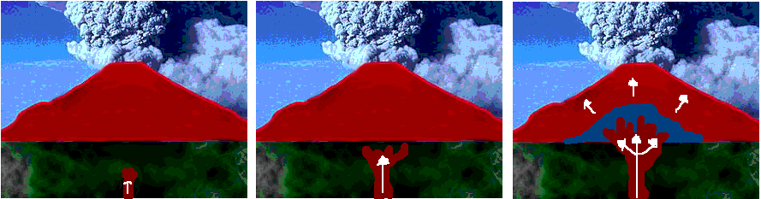
Volcano
火山

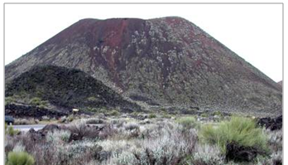
Cinder
Cone
锥形火山
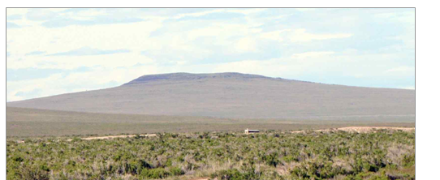
Shield
盾形火山

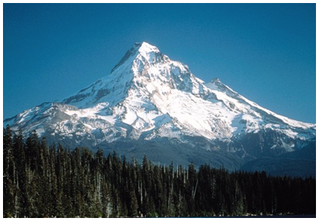
Composite
复合式火山
Mountains
山脉
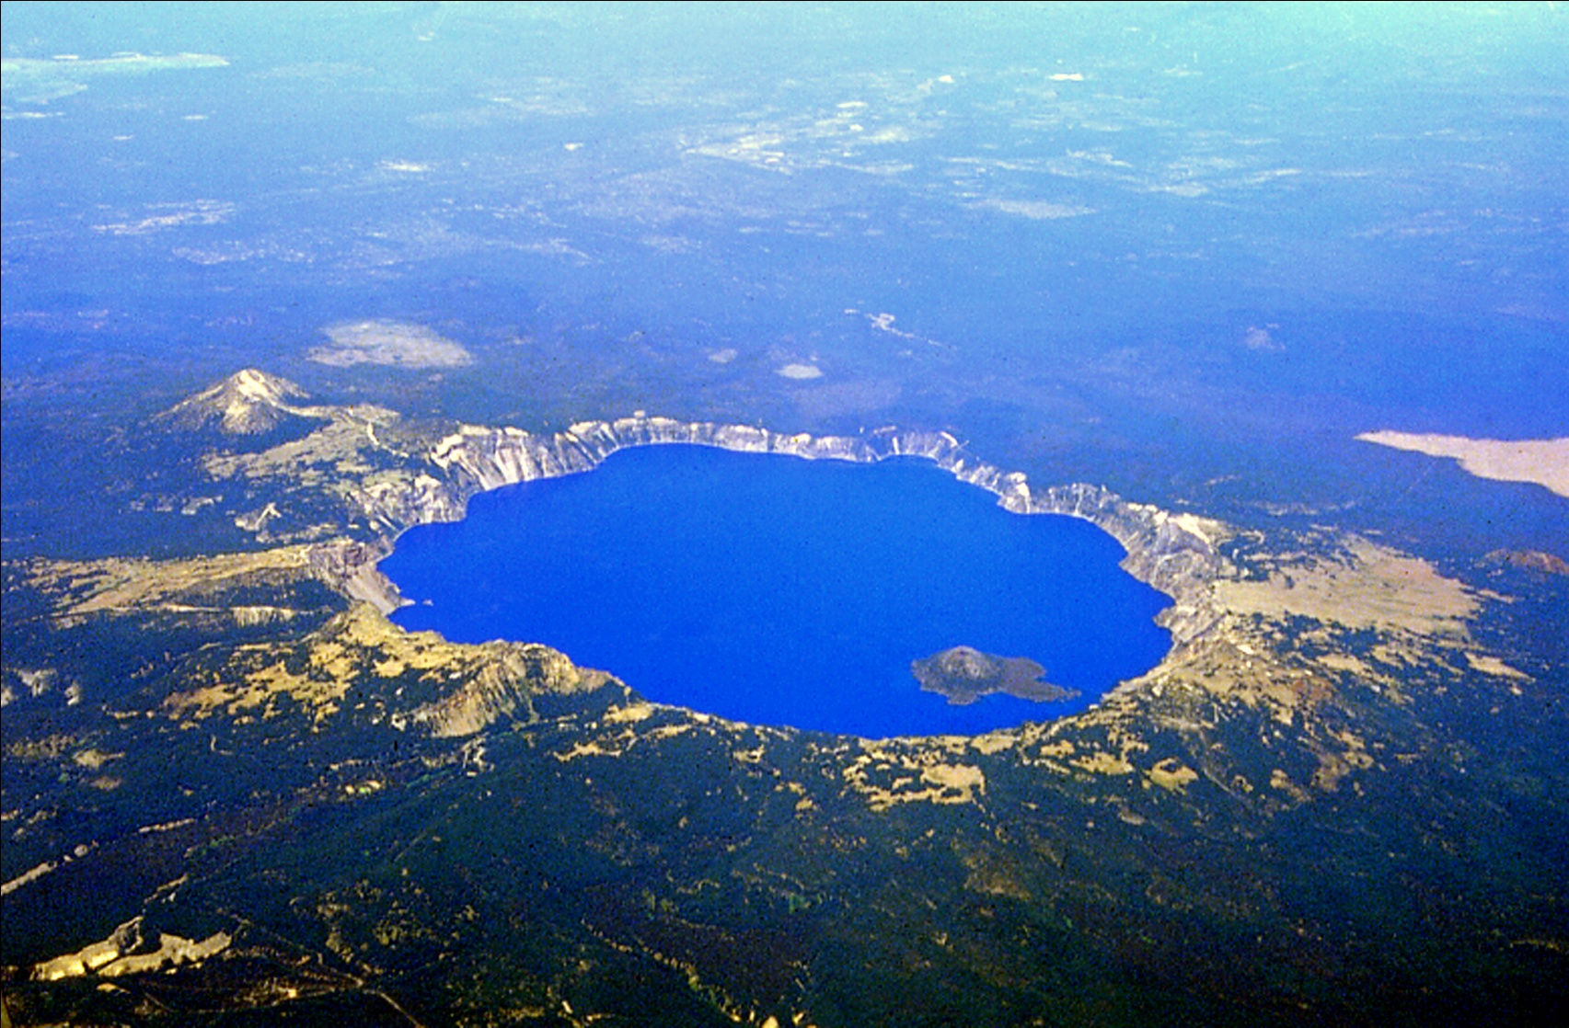
Crater
火山口
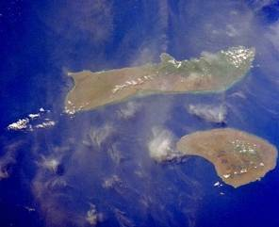
Island
岛屿
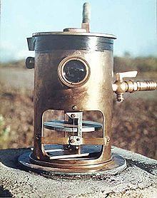
Tiltmeter
斜度仪

What is one landform a volcano can create?  火山能够形成哪种地貌？  Volcanoes can create ______ by ______.  火山通过______ 能够形成______ | What is a volcano?  什么是火山？  A volcano is ________.  火山是______
What is one type of volcano and what are its features?  火山的其中一个种类是什么？有什么特点？  One type of volcano is __________. It _________________________________.  其中一个种类是______ 它 ______ | What is another type of volcano and what are its features?  火山的另外一个种类是什么？有什么特点？  Another type of volcano is __________. It _________________________________.  另外一个是______它_________
What is another type of volcano and what are its features?  火山的另外一个种类是什么？有什么特点？  Another type of volcano is __________. It _________________________________.  另外一个是______它__________ | How can scientists predict volcanoes?  科学家如何预测火山喷发？  Scientists can predict volcanoes by ______.  ______  科学家用__________来预测火山喷发。

What is one landform a volcano can create?  Volcanoes can create ______ by ______. | What is a volcano?  A volcano is ________.
What is one type of volcano and what are its features?  One type of volcano is __________. It _________________________________. | What is another type of volcano and what are its features?  Another type of volcano is __________. It _________________________________.
What is another type of volcano and what are its features?  Another type of volcano is __________. It _________________________________. | How can scientists predict volcanoes?  Scientists can predict volcanoes by ______.

Name ______________________________________

姓名

-----------------------------------------------------------------------------------------------------

What is a volcano?
什么是火山？

__________________________________________________________________________________________

__________________________________________________________________________________________

___________________________________________________________________________________________
1

What is one landform a volcano can create?
火山能够形成哪种地貌？

__________________________________________________________________________________________

__________________________________________________________________________________________

___________________________________________________________________________________________

2
-----------------------------------------------------------------------------------------------------

What is another landform a volcano can create?

火山能够形成另外的哪一种地貌？

__________________________________________________________________________________________

__________________________________________________________________________________________

___________________________________________________________________________________________
3

What is another landform a volcano can create?

火山能够形成另外的哪一种地貌？

__________________________________________________________________________________________

__________________________________________________________________________________________

___________________________________________________________________________________________

4

-----------------------------------------------------------------------------------------------------

What is one type of volcano and what are its features?
火山的其中一个种类是什么？有什么特点？

__________________________________________________________________________________________

__________________________________________________________________________________________

___________________________________________________________________________________________
5

What is another type of volcano and what are its features?

火山的其中一个种类是什么？有什么特点？

__________________________________________________________________________________________

__________________________________________________________________________________________

___________________________________________________________________________________________

6

-----------------------------------------------------------------------------------------------------

What is another type of volcano and what are its features?
火山的其中一个种类是什么？有什么特点？

__________________________________________________________________________________________

__________________________________________________________________________________________

___________________________________________________________________________________________
7
How can scientists predict volcanoes?
科学家如何预测火山喷发？

__________________________________________________________________________________________

__________________________________________________________________________________________

___________________________________________________________________________________________

8

-----------------------------------------------------------------------------------------------------

